**DSA0187:OBJECT ORIENTED PROGRAMMING WITH C++**

DATE :15/03/2024

1. Define a C++ class named **Car** with a constructor that initializes a member variable **model** to "Unknown". Write a program to create an object of the **Car** class and display its model.

Program:

#include<iostream>

#include<string>

using namespace std;

class Car

{

private:

string model;

public:

Car(){

model="unknown";

}

string getModel()

{

return model;

}

};

int main(){

Car myCar;

cout<<"the model of the car is:"<<myCar.getModel()<<endl;

return 0;

}

Output:

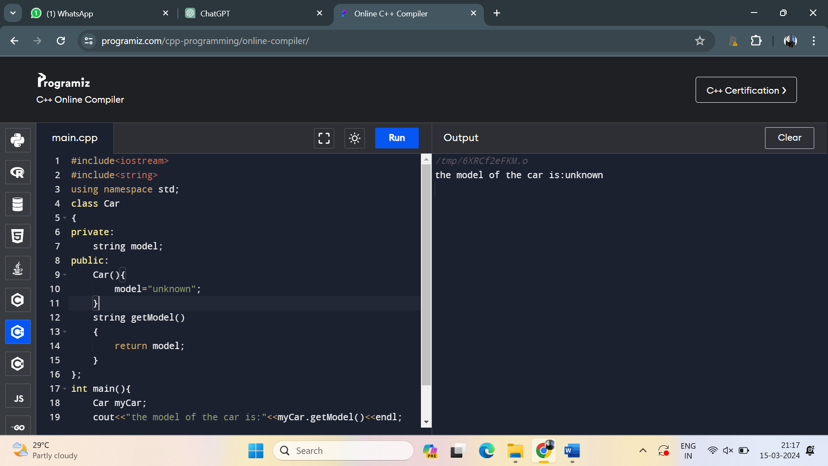

2. Extend the **Car** class from the previous question to have a parameterized constructor that sets the model based on user input. Write a program to create an object of the **Car** class with a specific model and display it.

Program:

#include<iostream>

using namespace std;

class car

{

private:

string model;

public:

car()

{

model="unknown";

}

car(string newModel)

{

model=newModel;

}

string getModel()

{

return model;

}

};

int main()

{

string userInput;

cout<<"enter model of the car:";

cin>>userInput;

car mycar(userInput);

cout<<"the model of the car is:"<<mycar.getModel()<<"\n";

return 0;

}

Output:

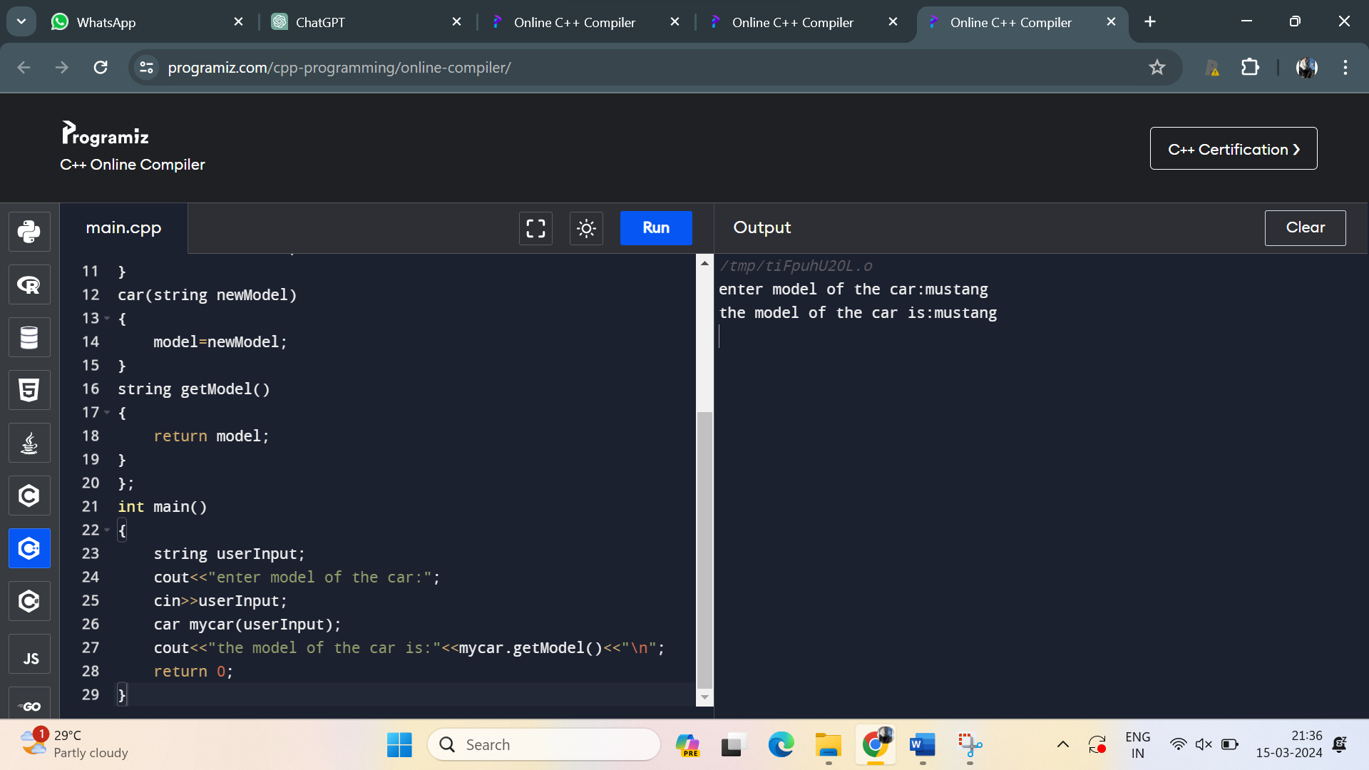

3. Define a C++ class named **Rectangle** with two constructors - one with default values for length and width, and another with parameters to set the length and width. Write a program to create objects of the **Rectangle** class using both constructors and display their dimensions.

Program:

#include<iostream>

using namespace std;

class rectangle

{

private:

int length;

int width;

public:

rectangle()

{

length=1;

width=1;

}

rectangle(int len,int wid)

{

length=len;

width=wid;

}

int getLength()

{

return length;

}

int getWidth()

{

return width;

}

};

int main()

{

int userInput1,userInput2;

cout<<"enter length of rectangle:";

cin>>userInput1;

cout<<"enter width of rectangle:";

cin>>userInput2;

rectangle myrect(userInput1,userInput2);

cout<<"the length and width of a rectangle is:"<<myrect.getLength()<<" ,"<<myrect.getWidth()<<"\n";

return 0;

}

Output:

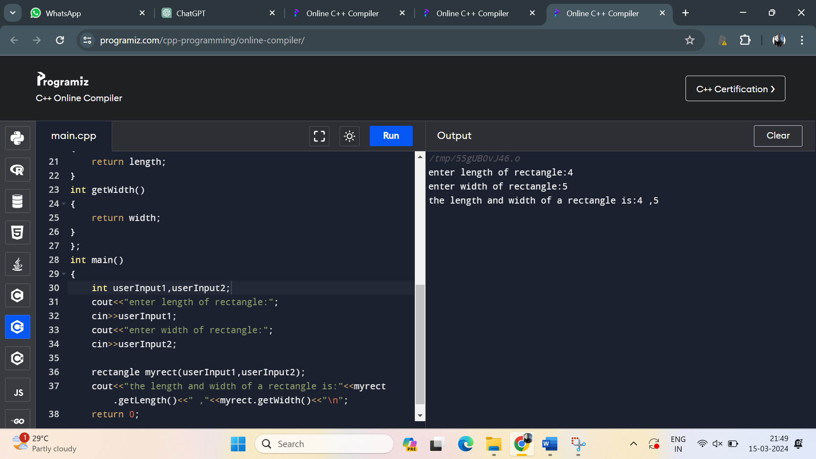

4. Create a C++ class named **Person** with member variables **name** and **age**. Implement a copy constructor to initialize a new object with the same values as an existing object. Write a program to demonstrate the use of the copy constructor.

Program:

#include <iostream>

#include <string>

using namespace std;

class Person {

private:

std::string name;

int age;

public:

// Constructor

Person(string n, int a) : name(n), age(a) {}

// Copy Constructor

Person(const Person &other) {

name = other.name;

age = other.age;

}

// Method to get name

std::string getName() {

return name;

}

// Method to get age

int getAge() {

return age;

}

};

int main() {

// Creating an object of the Person class

Person person1("Alice", 30);

// Using the copy constructor to create another object

Person person2 = person1;

// Displaying details of both persons

std::cout << "Person 1: Name = " << person1.getName() << ", Age = " << person1.getAge() << std::endl;

std::cout << "Person 2: Name = " << person2.getName() << ", Age = " << person2.getAge() << std::endl;

return 0;

}

Output:

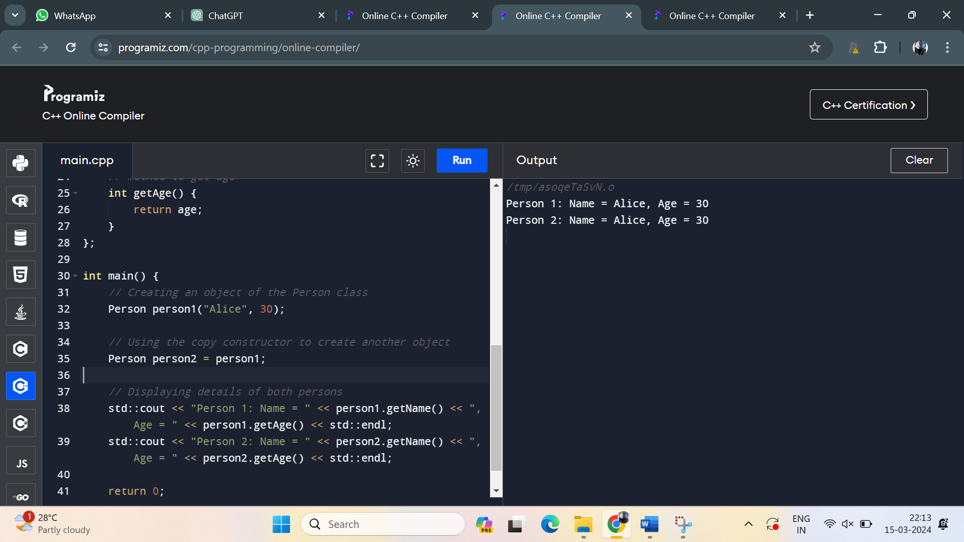

5. Define a C++ class named **DynamicArray** with a constructor that dynamically allocates an array of integers of a specified size. Implement a destructor to deallocate the memory. Write a program to create an object of the **DynamicArray** class and display its elements.

Program:

#include <iostream>

class DynamicArray {

private:

int* array;

int size;

public:

// Constructor

DynamicArray(int sz) {

size = sz;

array = new int[size];

}

// Destructor

~DynamicArray() {

delete[] array;

}

// Method to display elements

void displayElements() {

std::cout << "Elements of the DynamicArray: ";

for (int i = 0; i < size; ++i) {

std::cout << array[i] << " ";

}

std::cout << std::endl;

}

};

int main() {

// Creating an object of the DynamicArray class

DynamicArray dynamicArray(5); // Creating an array of size 5

// Displaying elements of the DynamicArray

dynamicArray.displayElements();

return 0;

}

Output:

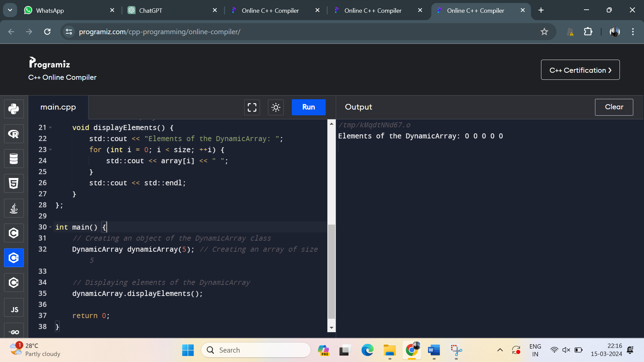

6. Extend the **Person** class from question 4 with a destructor to display a goodbye message when an object is destroyed. Write a program to demonstrate the destruction of **Person** objects.

Program:

#include <iostream>

#include <string>

class Person {

private:

std::string name;

int age;

public:

// Constructor

Person(std::string n, int a) : name(n), age(a) {}

// Destructor

~Person() {

std::cout << "Goodbye, " << name << "!\n";

}

// Method to get name

std::string getName() {

return name;

}

// Method to get age

int getAge() {

return age;

}

};

int main() {

// Creating objects of the Person class

Person* person1 = new Person("Alice", 30);

Person* person2 = new Person("Bob", 25);

// Deleting objects

delete person1;

delete person2;

return 0;

}

Output:

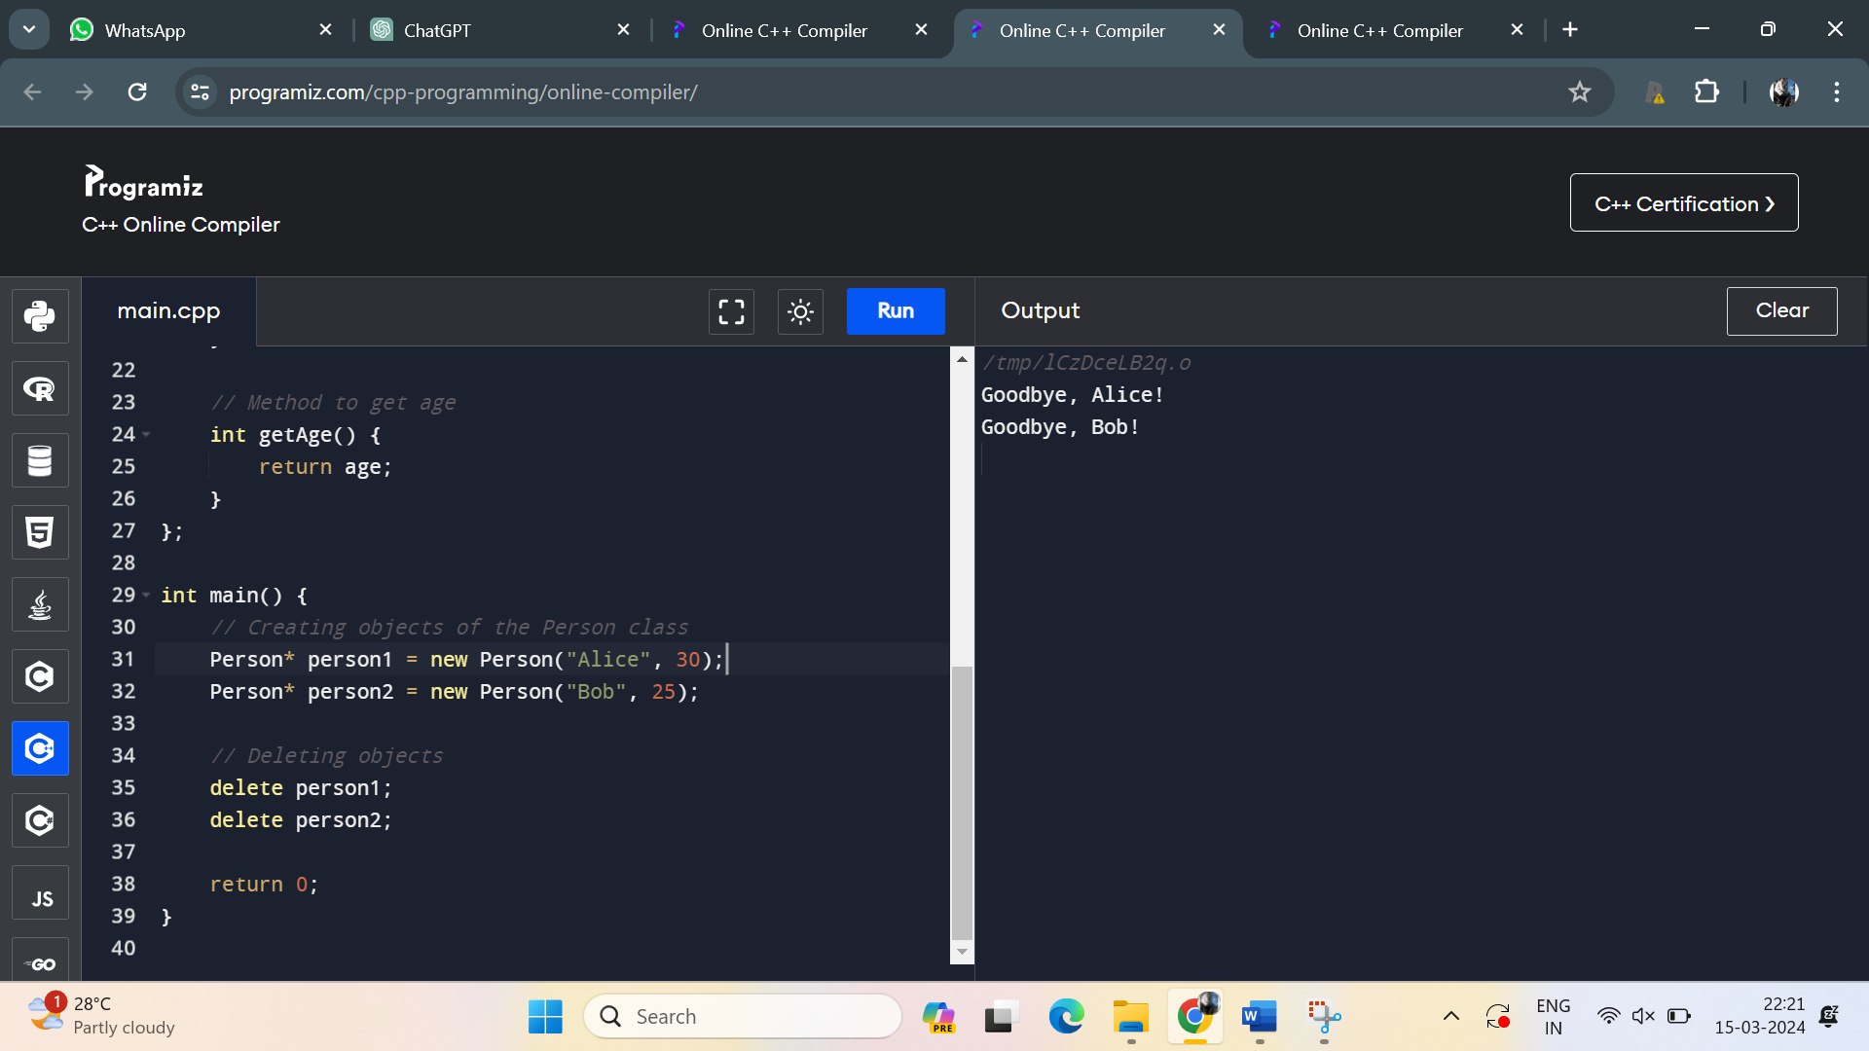

7. Define a C++ class named **Point** representing a 2D point with member variables **x** and **y**. Implement operator overloading for the addition operator (+) to add two **Point** objects together. Write a program to demonstrate the operator overloading.

Program:

#include <iostream>

class Point {

private:

double x;

double y;

public:

// Constructor

Point(double x_val = 0.0, double y_val = 0.0) : x(x_val), y(y_val) {}

// Overloading addition operator

Point operator+(const Point& other) const {

return Point(x + other.x, y + other.y);

}

// Method to display point coordinates

void display() const {

std::cout << "(" << x << ", " << y << ")";

}

};

int main() {

// Creating Point objects

Point point1(1.0, 2.0);

Point point2(3.0, 4.0);

// Adding two Point objects using overloaded operator

Point sum = point1 + point2;

// Displaying the result

std::cout << "Sum of ";

point1.display();

std::cout << " and ";

point2.display();

std::cout << " is ";

sum.display();

std::cout << std::endl;

return 0;

}

Output:

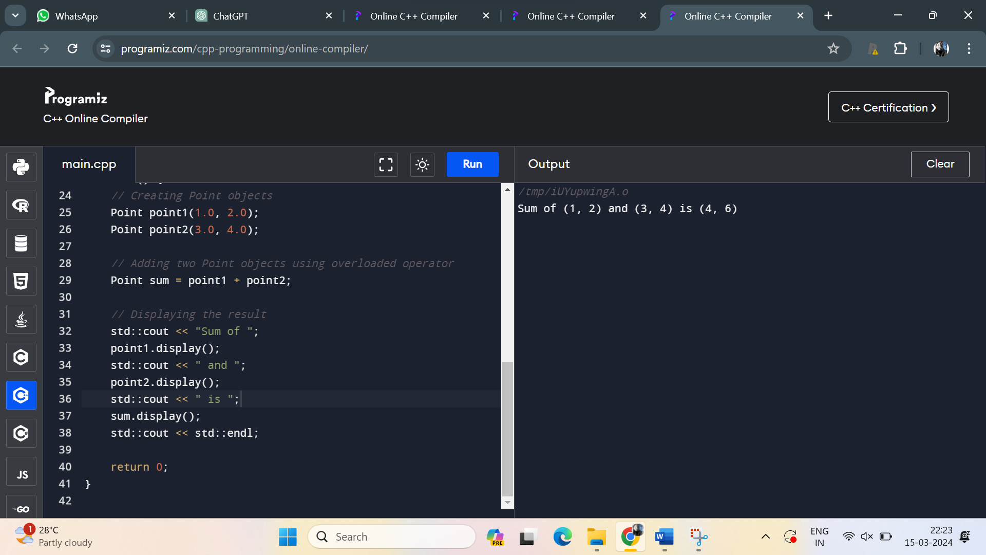

8. Extend the **Rectangle** class from question 3 to overload the addition operator (+) to add the areas of two rectangles together. Write a program to demonstrate the operator overloading.

Program:

#include <iostream>

class Rectangle {

private:

double length;

double width;

public:

// Constructors

Rectangle(double len = 1.0, double wid = 1.0) : length(len), width(wid) {}

// Method to calculate the area of the rectangle

double area() const {

return length * width;

}

// Overloading addition operator

double operator+(const Rectangle& other) const {

return this->area() + other.area();

}

// Method to display dimensions

void displayDimensions() const {

std::cout << "Length: " << length << ", Width: " << width << std::endl;

}

};

int main() {

// Creating two Rectangle objects

Rectangle rect1(3.0, 4.0);

Rectangle rect2(5.0, 6.0);

// Adding areas of two rectangles

double totalArea = rect1 + rect2;

// Displaying the dimensions of both rectangles and the total area

std::cout << "Rectangle 1:" << std::endl;

rect1.displayDimensions();

std::cout << "Rectangle 2:" << std::endl;

rect2.displayDimensions();

std::cout << "Total area of both rectangles: " << totalArea << std::endl;

return 0;

}

Output:

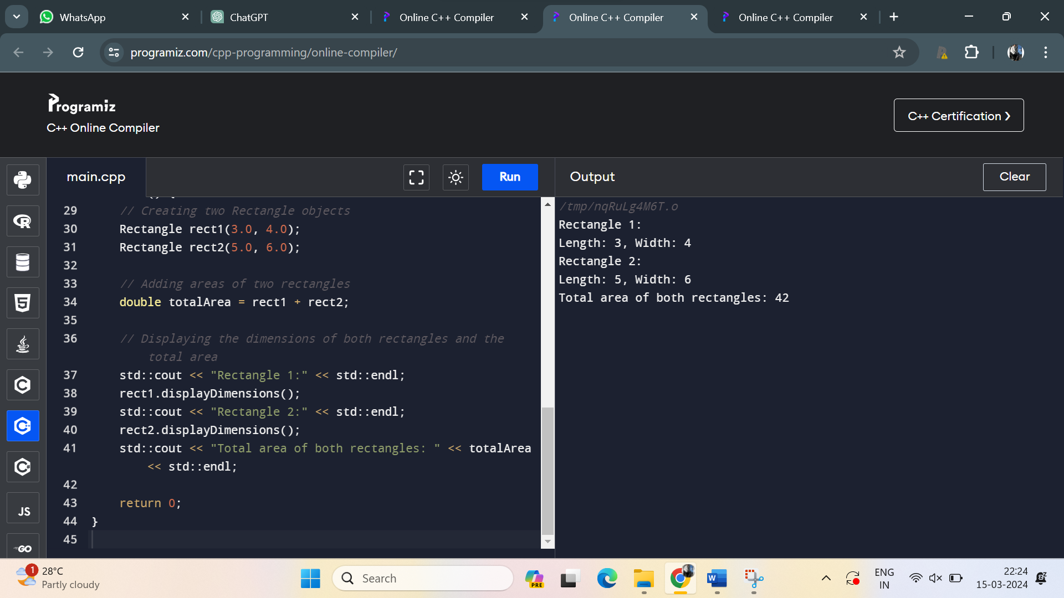

9. Define a C++ class named **Complex** representing a complex number with real and imaginary parts. Implement operator overloading for the addition, subtraction, and multiplication operators (+, -, *) to perform arithmetic operations on **Complex** objects. Write a program to demonstrate the operator overloading.

Program:

#include <iostream>

class Complex {

private:

double real;

double imag;

public:

// Constructor

Complex(double r = 0.0, double i = 0.0) : real(r), imag(i) {}

// Overloading addition operator

Complex operator+(const Complex& other) const {

return Complex(real + other.real, imag + other.imag);

}

// Overloading subtraction operator

Complex operator-(const Complex& other) const {

return Complex(real - other.real, imag - other.imag);

}

// Overloading multiplication operator

Complex operator*(const Complex& other) const {

double real_part = real * other.real - imag * other.imag;

double imag_part = real * other.imag + imag * other.real;

return Complex(real_part, imag_part);

}

// Method to display complex number

void display() const {

std::cout << real << " + " << imag << "i";

}

};

int main() {

// Creating Complex objects

Complex c1(2.0, 3.0);

Complex c2(1.0, -2.0);

// Performing arithmetic operations using overloaded operators

Complex sum = c1 + c2;

Complex difference = c1 - c2;

Complex product = c1 * c2;

// Displaying results

std::cout << "c1: ";

c1.display();

std::cout << std::endl;

std::cout << "c2: ";

c2.display();

std::cout << std::endl;

std::cout << "Sum: ";

sum.display();

std::cout << std::endl;

std::cout << "Difference: ";

difference.display();

std::cout << std::endl;

std::cout << "Product: ";

product.display();

std::cout << std::endl;

return 0;

}

Output:

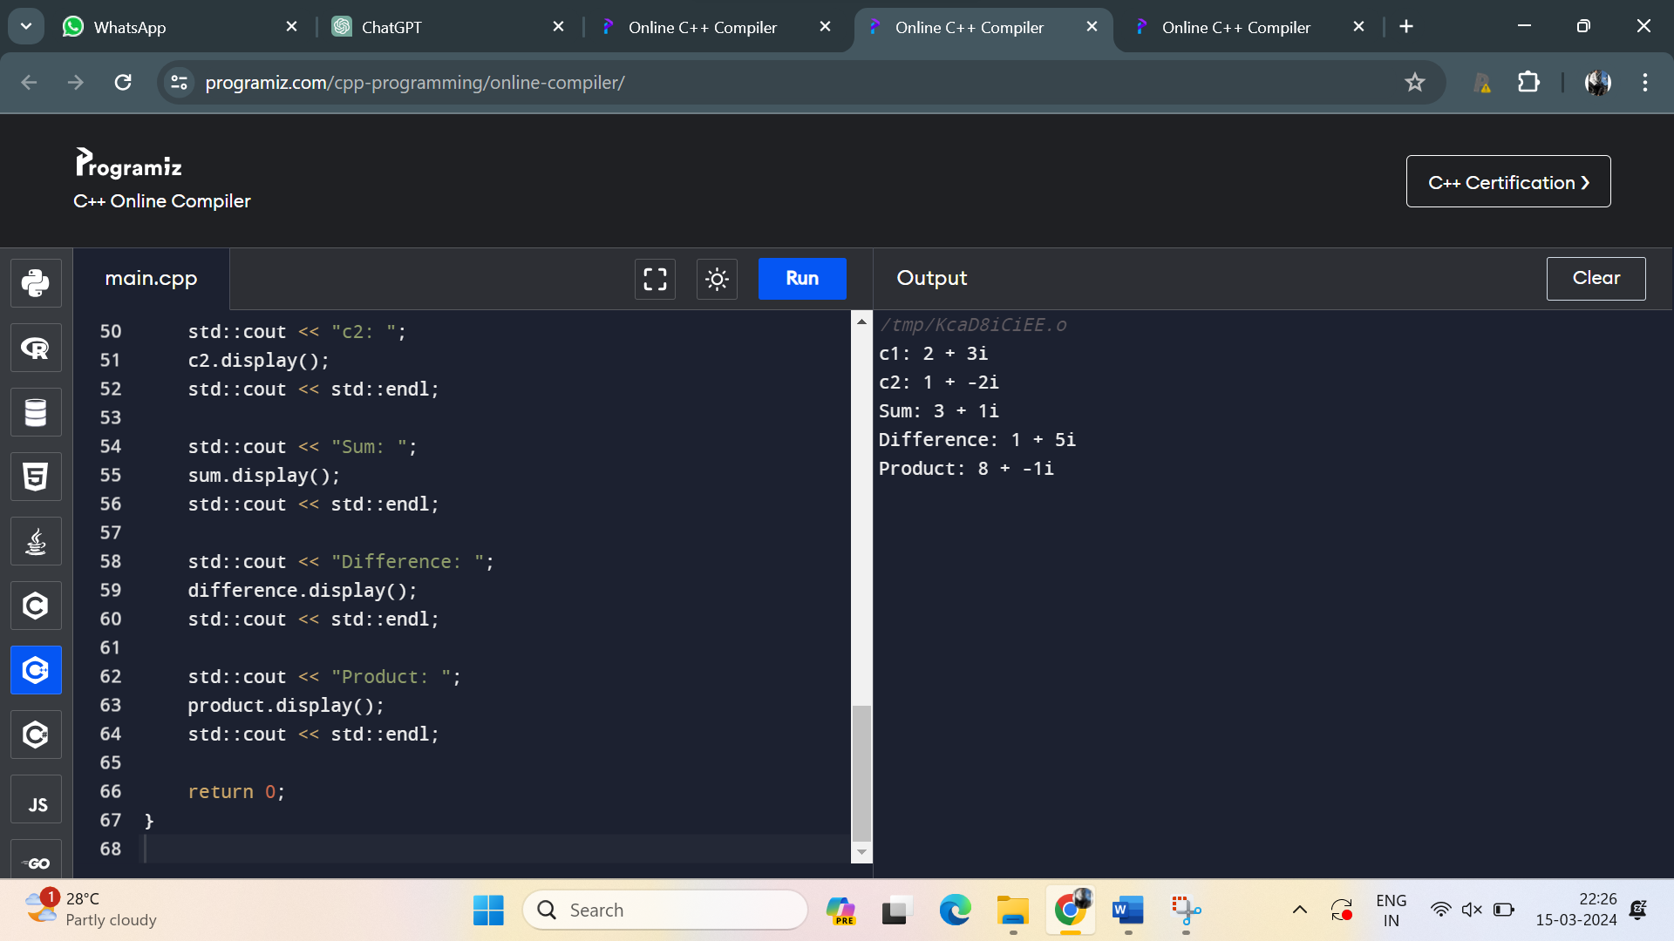

10. Define a C++ class called **Number** with a single integer member variable **value**. Overload the unary minus (-) operator to negate the value of a **Number** object. Write a program to demonstrate the unary minus operator overloading.

Program:

#include <iostream>

class Number {

private:

int value;

public:

// Constructor

Number(int val = 0) : value(val) {}

// Overloading unary minus operator

Number operator-() const {

return Number(-value);

}

// Method to get the value

int getValue() const {

return value;

}

};

int main() {

// Creating a Number object

Number num(10);

// Using unary minus operator to negate the value

Number negatedNum = -num;

// Displaying original and negated values

std::cout << "Original value: " << num.getValue() << std::endl;

std::cout << "Negated value: " << negatedNum.getValue() << std::endl;

return 0;

}

Output:

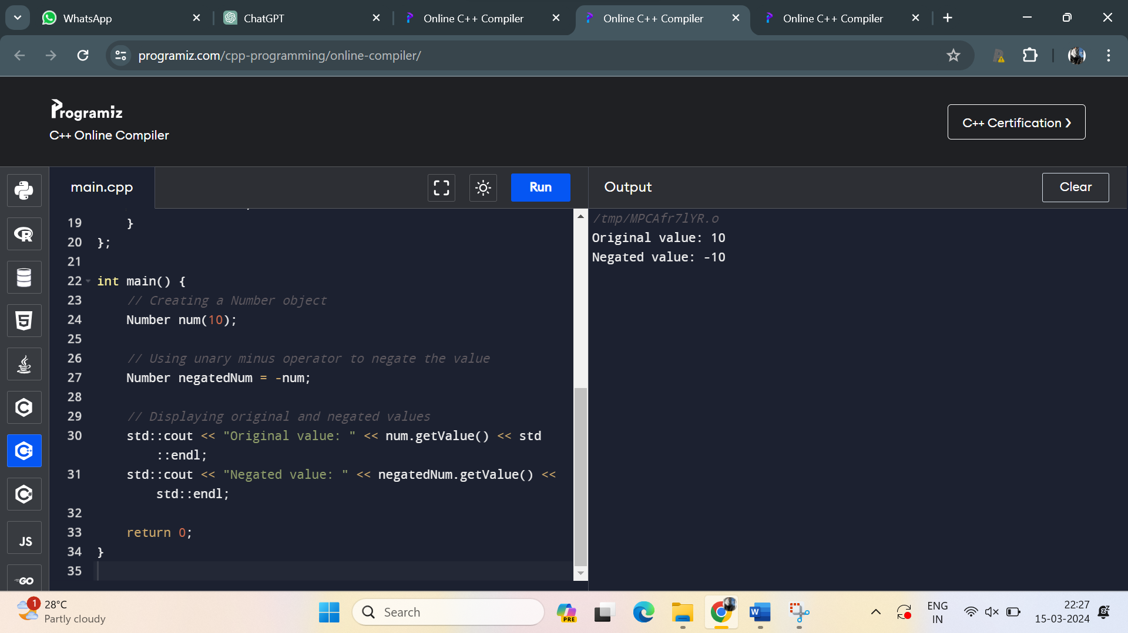

11. Create a class **Rectangle** with private attributes **length** and **width**. Implement a parameterized constructor to initialize these attributes. Also, include a function **calculateArea()** to compute and return the area of the rectangle.

Program:

#include <iostream>

class Rectangle {

private:

double length;

double width;

public:

// Parameterized constructor

Rectangle(double len, double wid) {

length = len;

width = wid;

}

// Function to calculate area

double calculateArea() {

return length * width;

}

};

int main() {

// Creating a Rectangle object with length 5 and width 4

Rectangle rect(5, 4);

// Calculating and printing the area

std::cout << "Area of the rectangle: " << rect.calculateArea() << std::endl;

return 0;

}

Output:

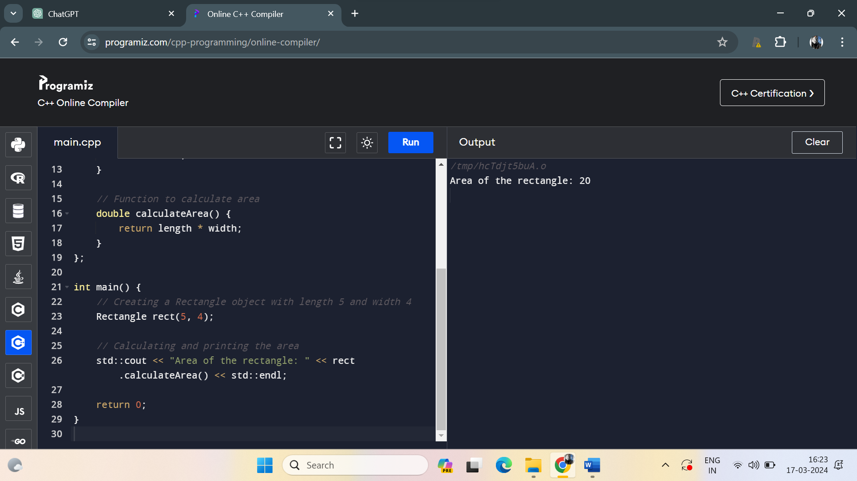

12. Define a class **Student** with private attributes **name** and **age**. Implement a default constructor that sets the name to "Unknown" and age to 0. Also, overload the constructor to accept values for name and age. Write a member function to display the details of the student.

Program:

#include <iostream>

#include <string>

class Student {

private:

std::string name;

int age;

public:

// Default constructor

Student() : name("Unknown"), age(0) {}

// Overloaded constructor

Student(std::string newName, int newAge) : name(newName), age(newAge) {}

// Member function to display student details

void displayDetails() {

std::cout << "Name: " << name << std::endl;

std::cout << "Age: " << age << std::endl;

}

};

int main() {

// Creating objects of Student class

Student student1; // Default constructor will be called

Student student2("John", 20); // Overloaded constructor will be called

// Displaying details of students

std::cout << "Student 1 Details:" << std::endl;

student1.displayDetails();

std::cout << std::endl;

std::cout << "Student 2 Details:" << std::endl;

student2.displayDetails();

return 0;

}

Output:

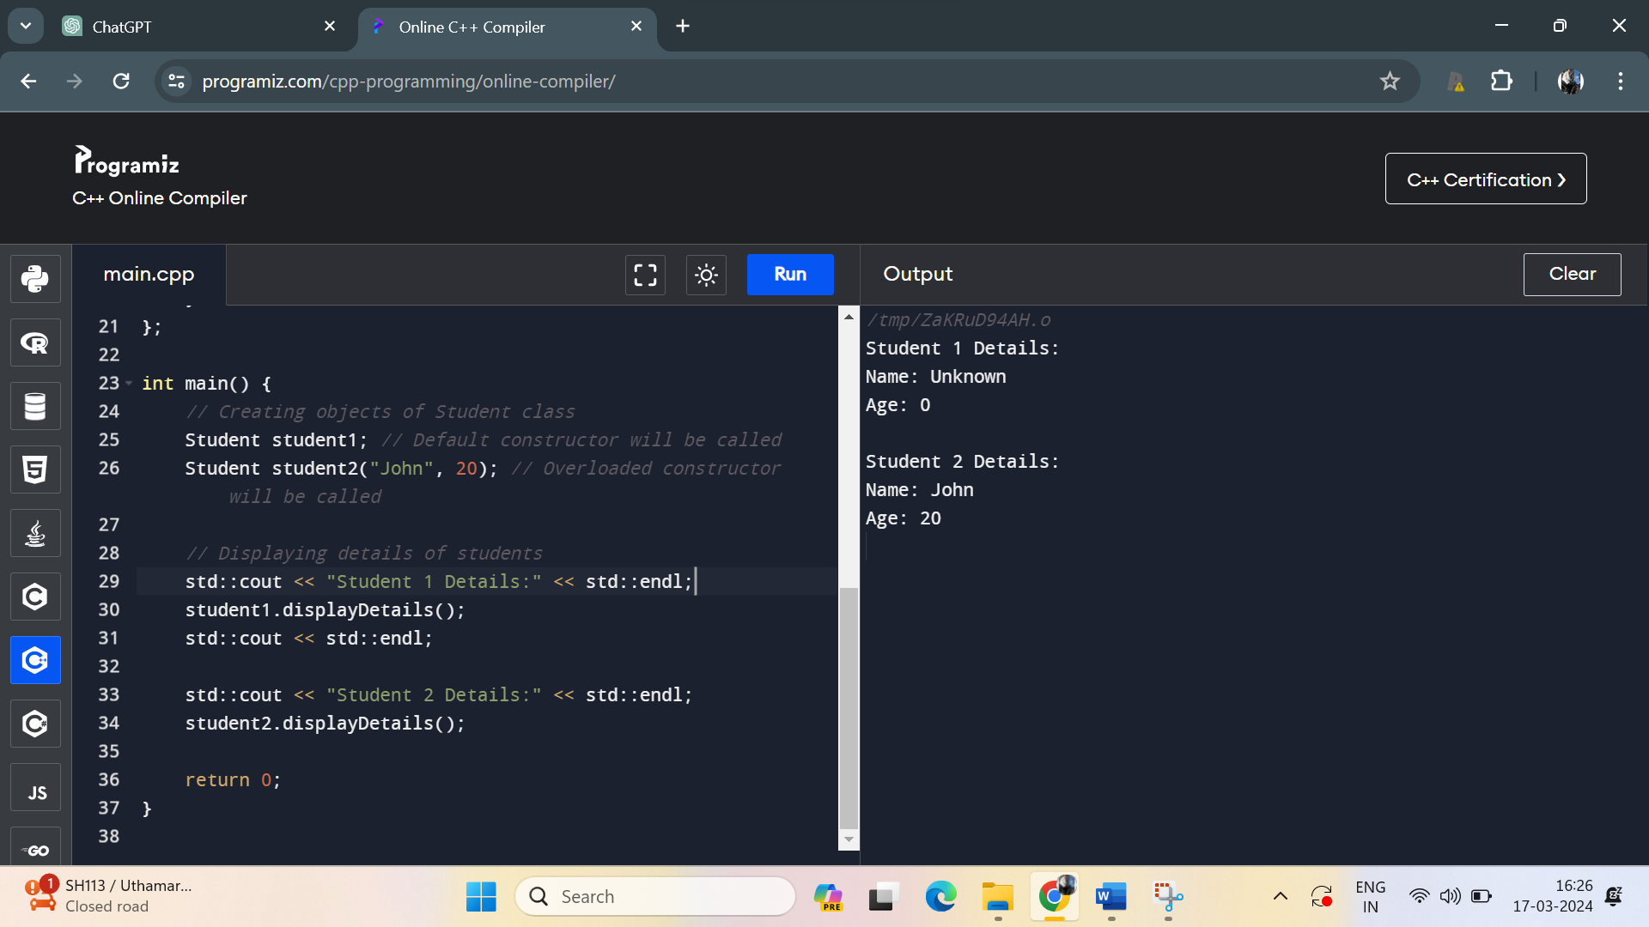

13. Create a class **Complex** to represent complex numbers. Implement a parameterized constructor to initialize real and imaginary parts. Overload the addition operator (+) to add two complex numbers.

Program:

#include <iostream>

class Complex {

private:

double real;

double imag;

public:

// Parameterized constructor

Complex(double r, double i) : real(r), imag(i) {}

// Overloading addition operator

Complex operator+(const Complex& other) {

double newReal = real + other.real;

double newImag = imag + other.imag;

return Complex(newReal, newImag);

}

// Function to display complex number

void display() {

std::cout << real << " + " << imag << "i";

}

};

int main() {

// Creating two Complex objects

Complex c1(2.5, 3.5);

Complex c2(1.2, 4.8);

// Adding two complex numbers using overloaded operator

Complex sum = c1 + c2;

// Displaying the result

std::cout << "Sum of ";

c1.display();

std::cout << " and ";

c2.display();

std::cout << " = ";

sum.display();

std::cout << std::endl;

return 0;

}

Output:

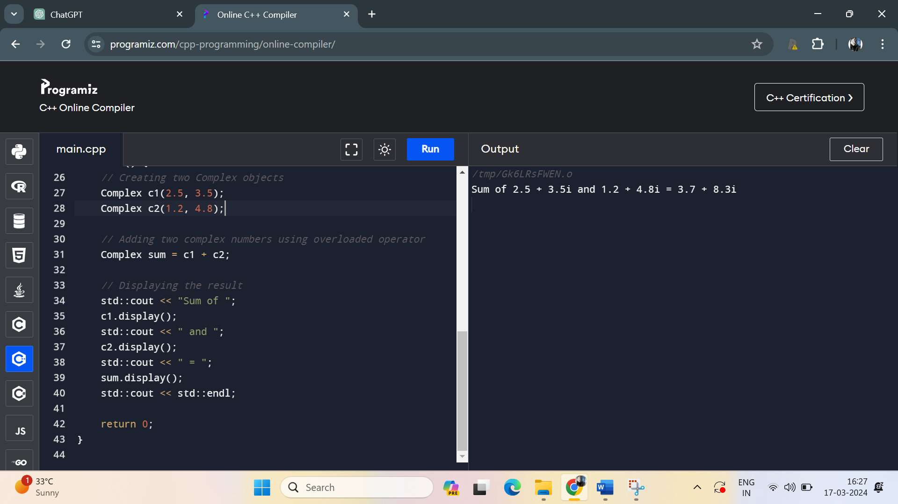

14. Write a class **String** to represent a string of characters. Implement a copy constructor to perform a deep copy of the string.

Program:

#include <iostream>

#include <cstring>

class String {

private:

char* str;

public:

// Constructor

String(const char* s) {

// Allocate memory for the string and copy characters

str = new char[strlen(s) + 1];

strcpy(str, s);

}

// Copy constructor

String(const String& other) {

// Allocate memory for the string and copy characters

str = new char[strlen(other.str) + 1];

strcpy(str, other.str);

}

// Destructor

~String() {

delete[] str; // Free allocated memory

}

// Function to display the string

void display() {

std::cout << "String: " << str << std::endl;

}

};

int main() {

// Create a String object

String str1("Hello");

// Use copy constructor to create another String object

String str2 = str1;

// Display both strings

str1.display();

str2.display();

return 0;

}

Output:

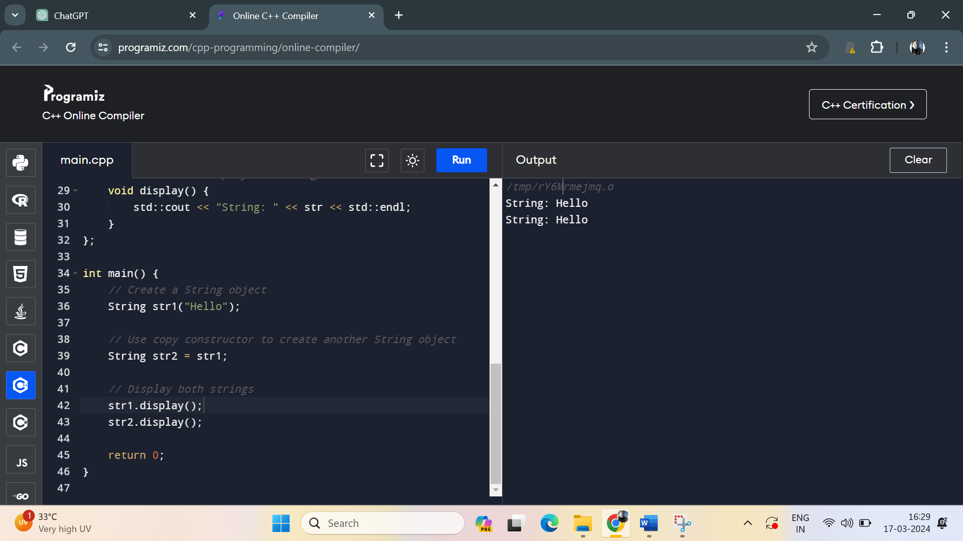15. Develop a class **DynamicArray** that acts as a dynamically resizable array. Implement a parameterized constructor that initializes the array with a specified size. Also, include a destructor to release the memory allocated for the array.

Program:

#include <iostream>

class DynamicArray {

private:

int* array;

int size;

public:

// Parameterized constructor

DynamicArray(int initialSize) {

size = initialSize;

array = new int[size];

}

// Destructor

~DynamicArray() {

delete[] array; // Free allocated memory

}

// Function to resize the array

void resize(int newSize) {

int* newArray = new int[newSize];

int minSize = (newSize < size) ? newSize : size;

for (int i = 0; i < minSize; ++i) {

newArray[i] = array[i];

}

delete[] array; // Free old memory

array = newArray;

size = newSize;

}

// Function to get the size of the array

int getSize() const {

return size;

}

// Function to display the elements of the array

void display() const {

std::cout << "Array elements: ";

for (int i = 0; i < size; ++i) {

std::cout << array[i] << " ";

}

std::cout << std::endl;

}

};

int main() {

// Create a DynamicArray object with initial size 5

DynamicArray arr(5);

// Display the initial array size and elements

std::cout << "Initial array size: " << arr.getSize() << std::endl;

arr.display();

// Resize the array to size 8

arr.resize(8);

// Display the resized array size and elements

std::cout << "Resized array size: " << arr.getSize() << std::endl;

arr.display();

return 0;

}

Output:

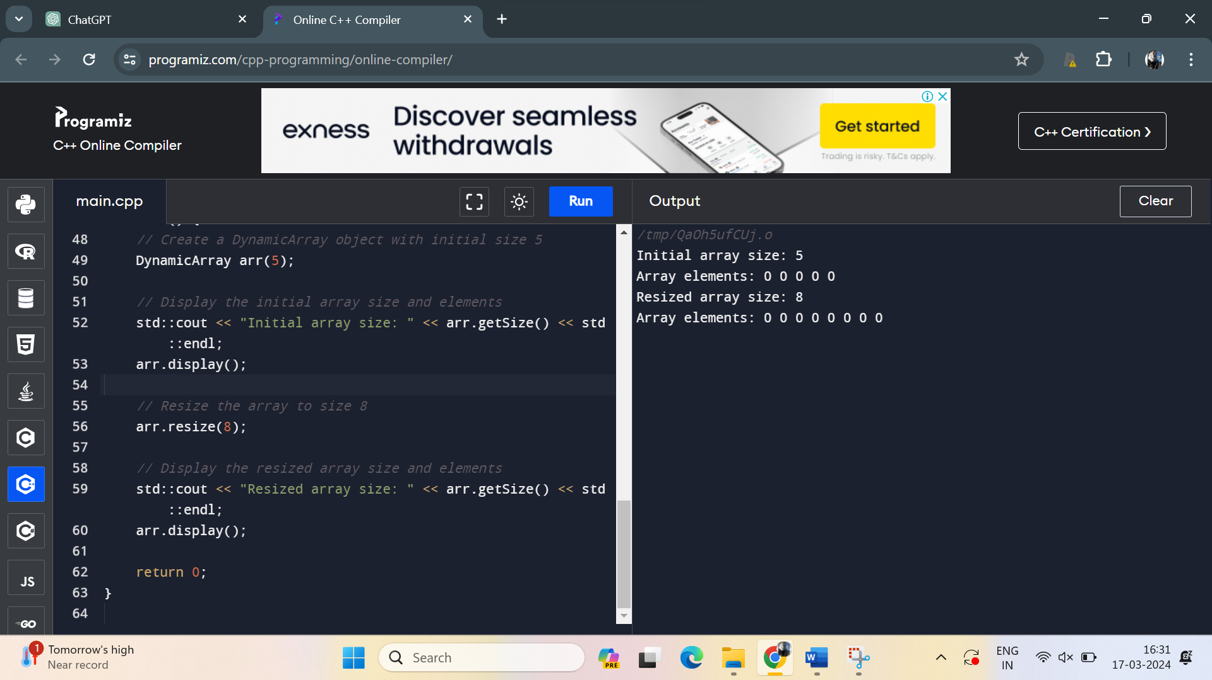16. Implement a class **Vector2D** to represent 2-dimensional vectors. Overload the addition operator (+) to add two vectors component-wise.

Program:

#include <iostream>

class Vector2D {

private:

double x;

double y;

public:

// Constructor

Vector2D(double x_val, double y_val) : x(x_val), y(y_val) {}

// Overloading addition operator

Vector2D operator+(const Vector2D& other) const {

return Vector2D(x + other.x, y + other.y);

}

// Function to display the vector

void display() const {

std::cout << "(" << x << ", " << y << ")";

}

};

int main() {

// Create two Vector2D objects

Vector2D v1(1.5, 2.5);

Vector2D v2(0.5, 1.5);

// Add the two vectors using the overloaded addition operator

Vector2D sum = v1 + v2;

// Display the result

std::cout << "v1 = ";

v1.display();

std::cout << std::endl;

std::cout << "v2 = ";

v2.display();

std::cout << std::endl;

std::cout << "Sum of v1 and v2 = ";

sum.display();

std::cout << std::endl;

return 0;

}

Output:

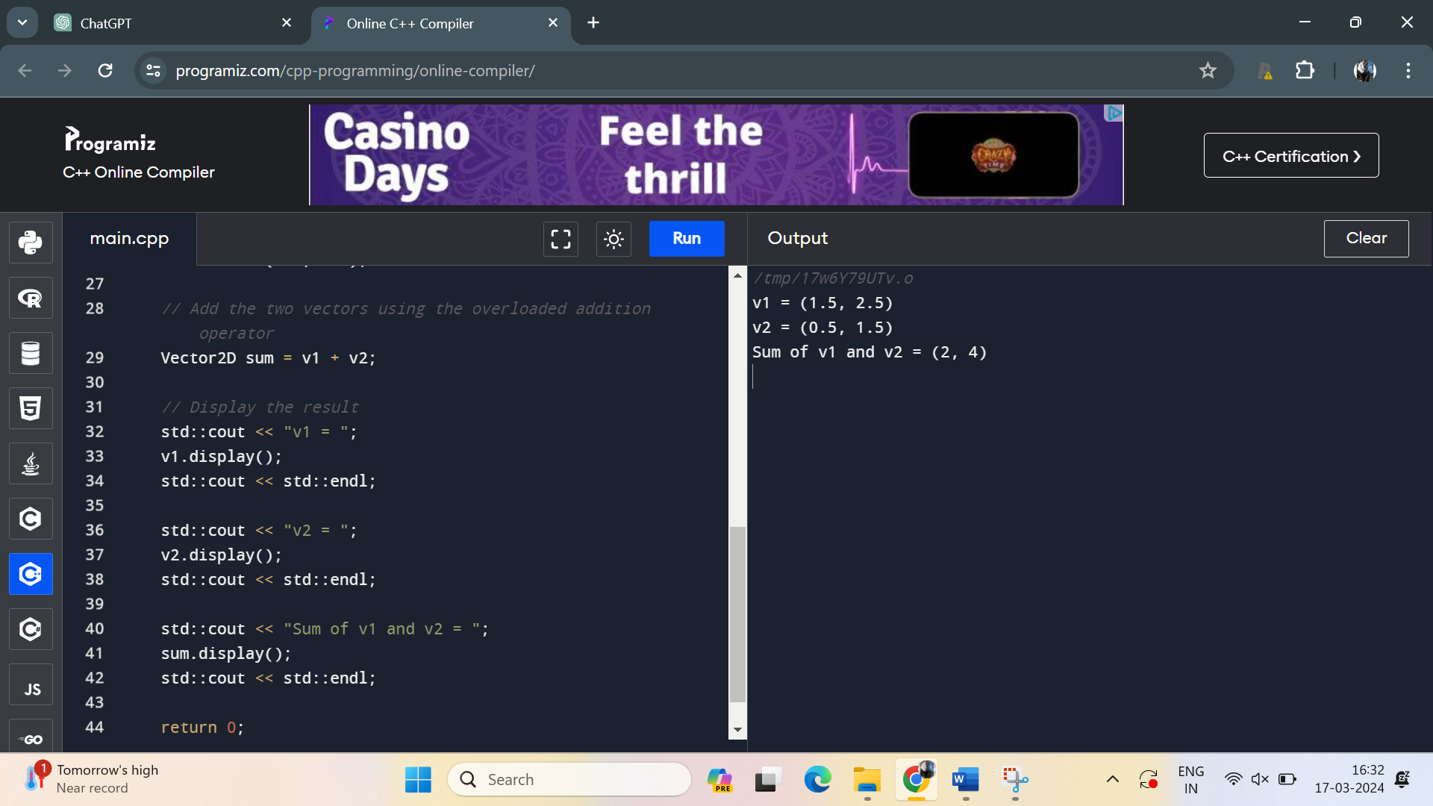

17. Create a class **Book** with private attributes **title**, **author**, and **pages**. Implement a parameterized constructor to initialize these attributes. Overload the comparison operators (== and !=) to compare two books based on their titles.

Program:

#include <iostream>

#include <string>

class Book {

private:

std::string title;

std::string author;

int pages;

public:

// Parameterized constructor

Book(const std::string& t, const std::string& a, int p)

: title(t), author(a), pages(p) {}

// Overloaded comparison operator (==)

bool operator==(const Book& other) const {

return title == other.title;

}

// Overloaded comparison operator (!=)

bool operator!=(const Book& other) const {

return title != other.title;

}

// Function to display book details

void display() const {

std::cout << "Title: " << title << std::endl;

std::cout << "Author: " << author << std::endl;

std::cout << "Pages: " << pages << std::endl;

}

};

int main() {

// Creating two Book objects

Book book1("Title1", "Author1", 200);

Book book2("Title2", "Author2", 300);

// Comparing books using overloaded operators

if (book1 == book2) {

std::cout << "The books have the same title." << std::endl;

} else {

std::cout << "The books have different titles." << std::endl;

}

if (book1 != book2) {

std::cout << "The books have different titles." << std::endl;

} else {

std::cout << "The books have the same title." << std::endl;

}

return 0;

}

Output:

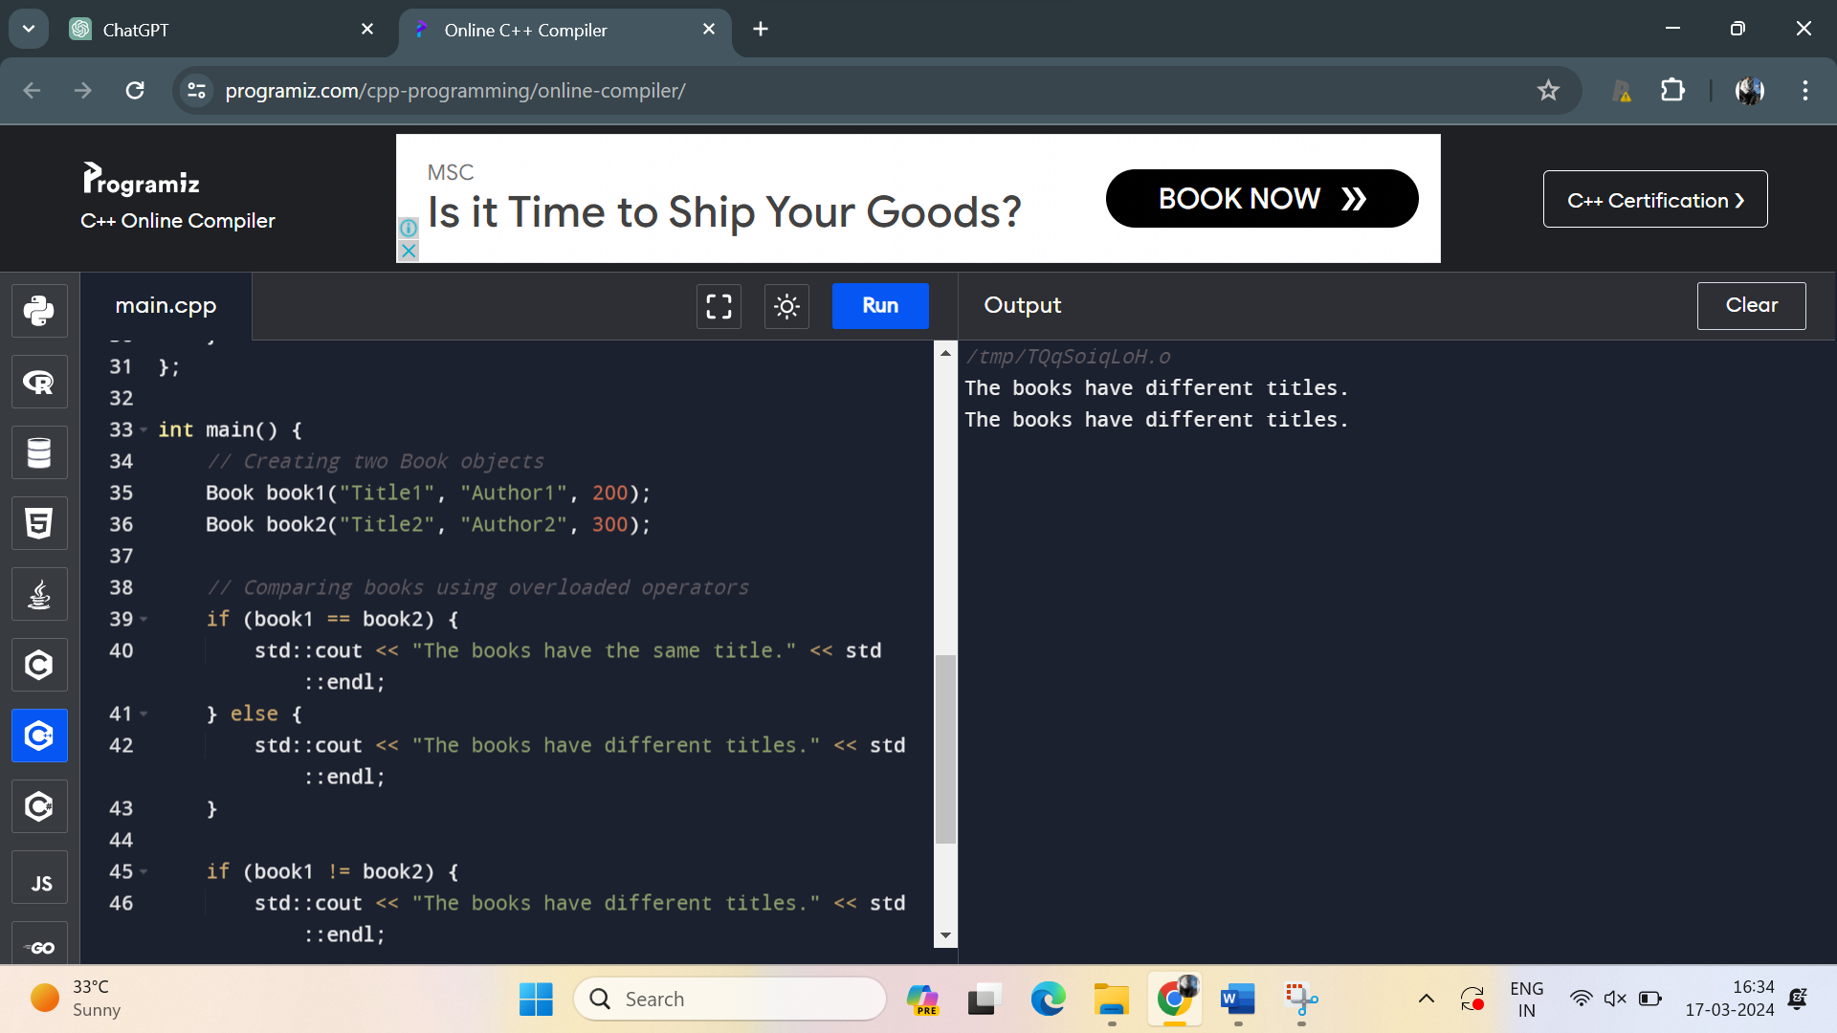

18. Define a class **Counter** to represent a simple counter. Include an integer attribute **count** and implement a default constructor that sets **count** to 0. Overload the prefix increment operator (++) to increment the counter.

Program:

#include <iostream>

class Counter {

private:

int count;

public:

// Default constructor

Counter() : count(0) {}

// Prefix increment operator (++counter)

Counter& operator++() {

++count;

return *this;

}

// Function to get the count value

int getCount() const {

return count;

}

};

int main() {

// Create a Counter object

Counter counter;

// Display the initial count

std::cout << "Initial count: " << counter.getCount() << std::endl;

// Increment the counter using the overloaded prefix increment operator

++counter;

// Display the incremented count

std::cout << "After increment: " << counter.getCount() << std::endl;

return 0;

}

Output:

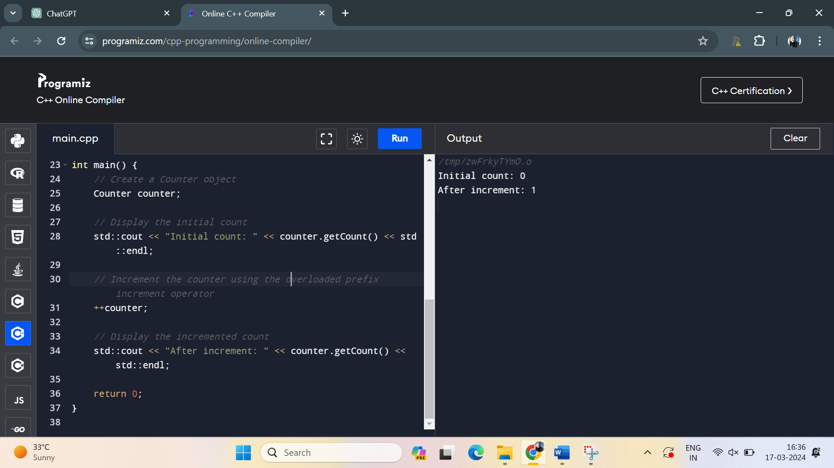

19. Write a class **Matrix** to represent a 2x2 matrix. Implement a parameterized constructor to initialize the matrix elements. Overload the multiplication operator (*) to perform matrix multiplication.

Program:

#include <iostream>

class Matrix {

private:

double data[2][2];

public:

// Parameterized constructor

Matrix(double a, double b, double c, double d) {

data[0][0] = a;

data[0][1] = b;

data[1][0] = c;

data[1][1] = d;

}

// Overloaded multiplication operator (*)

Matrix operator*(const Matrix& other) const {

Matrix result(0, 0, 0, 0);

for (int i = 0; i < 2; ++i) {

for (int j = 0; j < 2; ++j) {

for (int k = 0; k < 2; ++k) {

result.data[i][j] += data[i][k] * other.data[k][j];

}

}

}

return result;

}

// Function to display the matrix

void display() const {

for (int i = 0; i < 2; ++i) {

for (int j = 0; j < 2; ++j) {

std::cout << data[i][j] << " ";

}

std::cout << std::endl;

}

}

};

int main() {

// Create two Matrix objects

Matrix m1(1, 2, 3, 4);

Matrix m2(5, 6, 7, 8);

// Multiply the matrices using the overloaded multiplication operator

Matrix result = m1 * m2;

// Display the result

std::cout << "Result of matrix multiplication:" << std::endl;

result.display();

return 0;

}

Output:

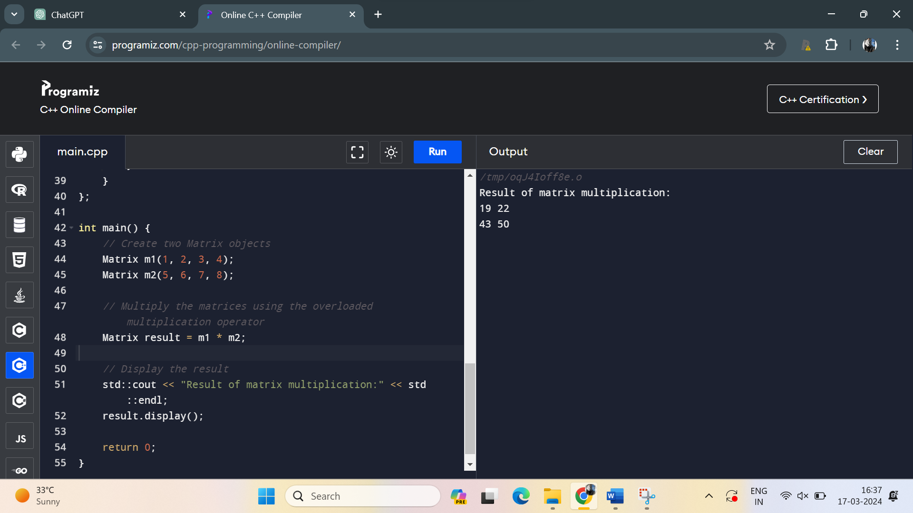

20. Develop a class **Date** to represent dates (day, month, year). Implement a default constructor that sets the date to January 1, 2000. Overload the stream insertion (<<) and extraction (>>) operators to read and write dates from/to standard input/output.

Program:

#include <iostream>

#include <iomanip> // For std::setw

class Date {

private:

int day;

int month;

int year;

public:

// Default constructor

Date() : day(1), month(1), year(2000) {}

// Parameterized constructor

Date(int d, int m, int y) : day(d), month(m), year(y) {}

// Overloading stream insertion operator (<<)

friend std::ostream& operator<<(std::ostream& out, const Date& date) {

out << std::setw(2) << std::setfill('0') << date.day << '/'

<< std::setw(2) << std::setfill('0') << date.month << '/'

<< date.year;

return out;

}

// Overloading stream extraction operator (>>)

friend std::istream& operator>>(std::istream& in, Date& date) {

char delimiter;

in >> date.day >> delimiter >> date.month >> delimiter >> date.year;

return in;

}

};

int main() {

// Create a Date object using default constructor

Date defaultDate;

std::cout << "Default date: " << defaultDate << std::endl;

// Read a Date from standard input

Date inputDate;

std::cout << "Enter a date (dd/mm/yyyy): ";

std::cin >> inputDate;

std::cout << "You entered: " << inputDate << std::endl;

return 0;

}

Output:

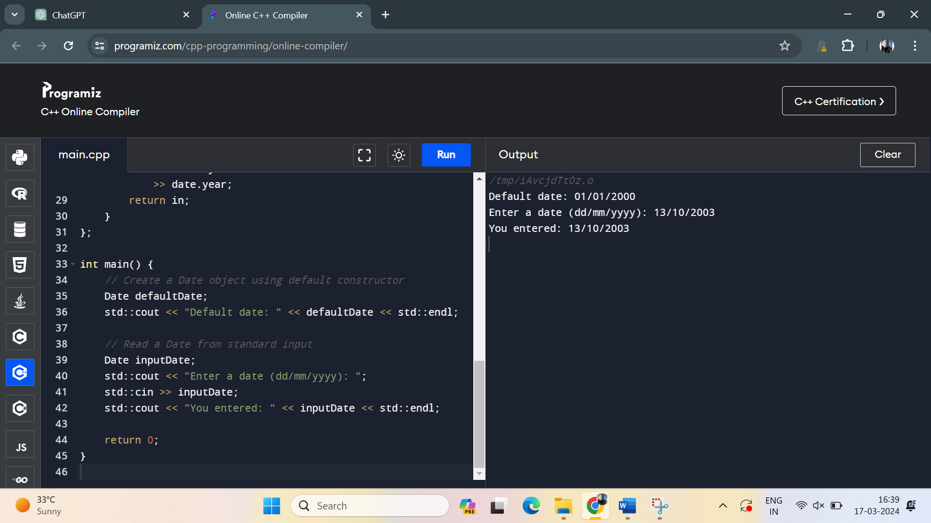

21. Implement a class **Matrix** to represent an arbitrary-sized matrix. Provide a parameterized constructor to initialize the matrix with the specified number of rows and columns. Implement a copy constructor to perform a deep copy of the matrix.

Program:

#include <iostream>

#include <vector>

class Matrix {

private:

std::vector<std::vector<int>> data;

int rows;

int cols;

public:

// Parameterized constructor

Matrix(int numRows, int numCols) : rows(numRows), cols(numCols) {

data.resize(rows, std::vector<int>(cols, 0));

}

// Copy constructor

Matrix(const Matrix& other) : rows(other.rows), cols(other.cols) {

data = other.data; // Deep copy

}

// Function to set value at a specific position

void setValue(int row, int col, int value) {

if (row >= 0 && row < rows && col >= 0 && col < cols) {

data[row][col] = value;

} else {

std::cerr << "Error: Index out of range!" << std::endl;

}

}

// Function to get value at a specific position

int getValue(int row, int col) const {

if (row >= 0 && row < rows && col >= 0 && col < cols) {

return data[row][col];

} else {

std::cerr << "Error: Index out of range!" << std::endl;

return 0; // Return 0 as a default value

}

}

// Function to display the matrix

void display() const {

for (int i = 0; i < rows; ++i) {

for (int j = 0; j < cols; ++j) {

std::cout << data[i][j] << " ";

}

std::cout << std::endl;

}

}

};

int main() {

// Create a Matrix object

Matrix mat1(3, 3);

// Set some values

mat1.setValue(0, 0, 1);

mat1.setValue(0, 1, 2);

mat1.setValue(0, 2, 3);

mat1.setValue(1, 0, 4);

mat1.setValue(1, 1, 5);

mat1.setValue(1, 2, 6);

mat1.setValue(2, 0, 7);

mat1.setValue(2, 1, 8);

mat1.setValue(2, 2, 9);

// Display the matrix

std::cout << "Matrix 1:" << std::endl;

mat1.display();

// Create a copy of Matrix object

Matrix mat2 = mat1;

// Display the copied matrix

std::cout << "\nCopied Matrix 2:" << std::endl;

mat2.display();

return 0;

}

Output:

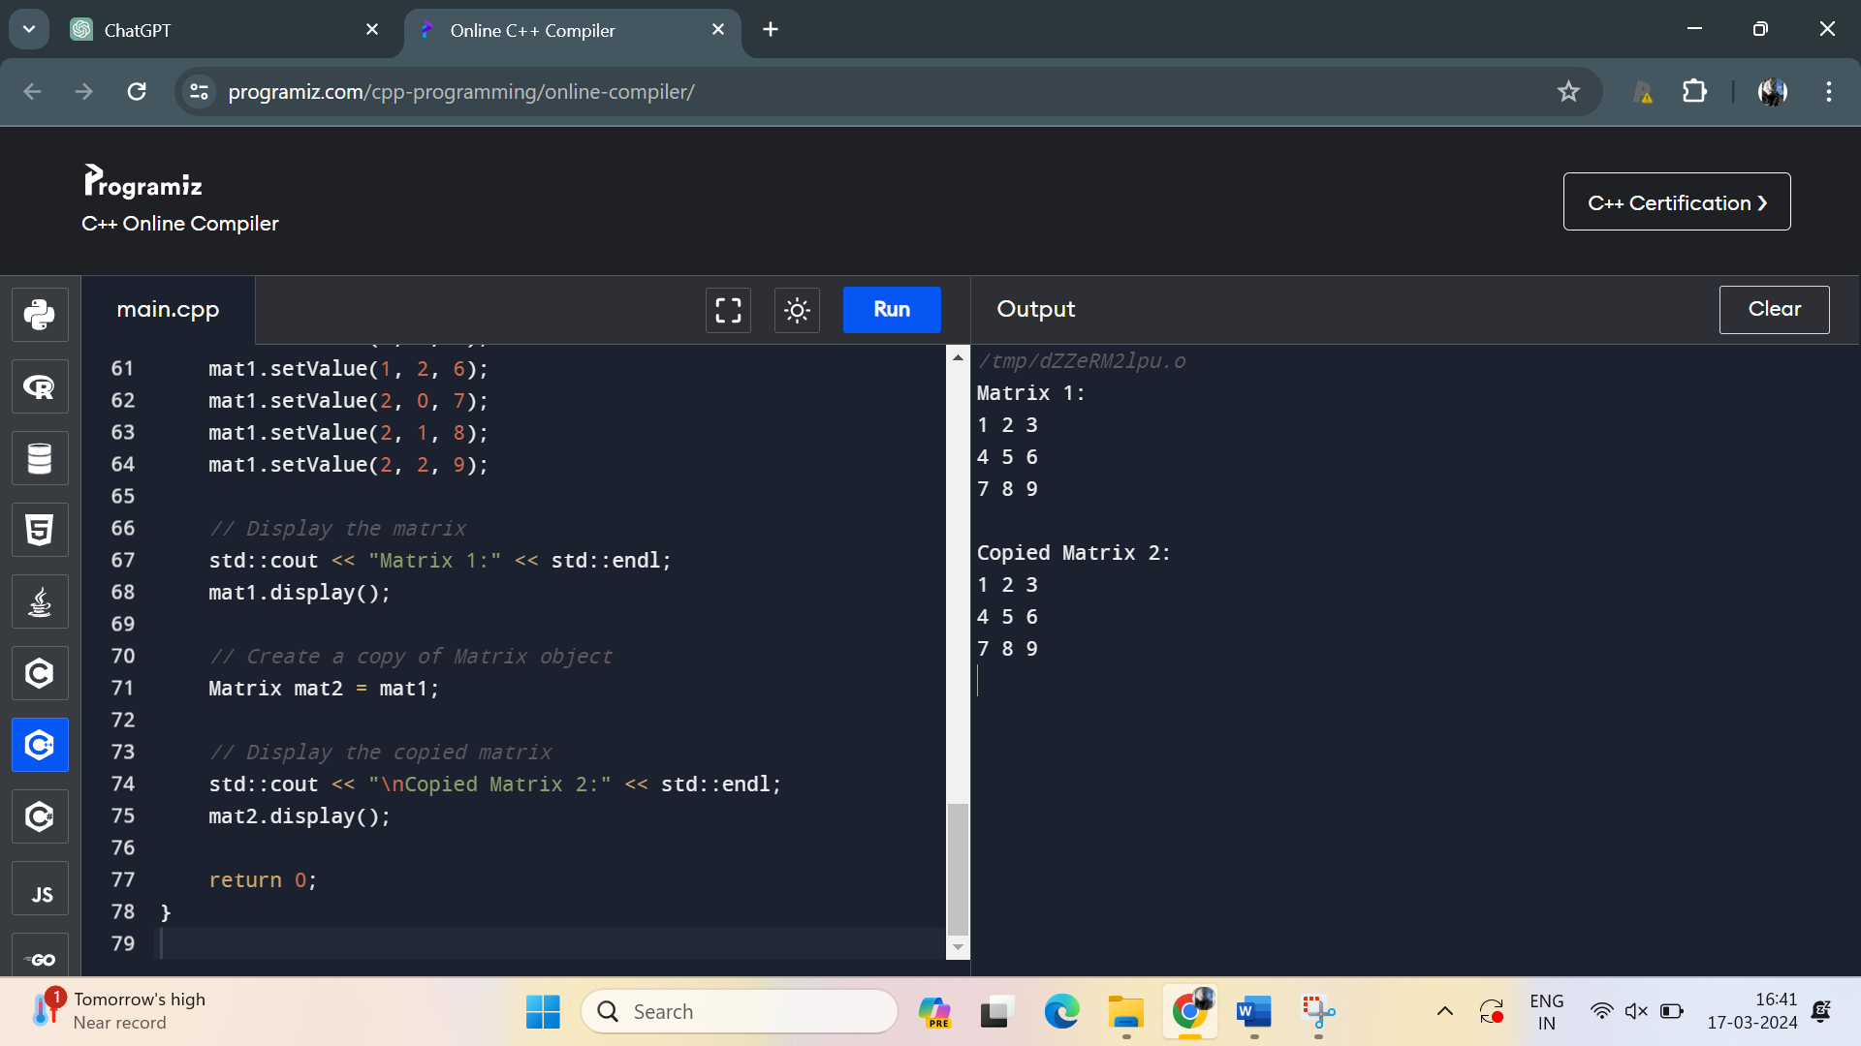

22. Create a class **LinkedList** to represent a linked list data structure. Implement a parameterized constructor to initialize the linked list with an array of elements. Include a destructor to free the memory allocated for the nodes.

Program:

#include <iostream>

class Node {

public:

int data;

Node* next;

Node(int value) : data(value), next(nullptr) {}

};

class LinkedList {

private:

Node* head;

public:

// Default constructor

LinkedList() : head(nullptr) {}

// Parameterized constructor to initialize with an array of elements

LinkedList(int arr[], int size) : head(nullptr) {

for (int i = 0; i < size; ++i) {

insert(arr[i]);

}

}

// Destructor to free the memory allocated for nodes

~LinkedList() {

Node* current = head;

while (current != nullptr) {

Node* temp = current;

current = current->next;

delete temp;

}

}

// Function to insert a new element at the end of the list

void insert(int value) {

Node* newNode = new Node(value);

if (head == nullptr) {

head = newNode;

} else {

Node* current = head;

while (current->next != nullptr) {

current = current->next;

}

current->next = newNode;

}

}

// Function to display the linked list

void display() const {

Node* current = head;

while (current != nullptr) {

std::cout << current->data << " ";

current = current->next;

}

std::cout << std::endl;

}

};

int main() {

// Create a LinkedList object using a parameterized constructor

int arr[] = {1, 2, 3, 4, 5};

int size = sizeof(arr) / sizeof(arr[0]);

LinkedList myList(arr, size);

// Display the linked list

myList.display();

return 0;

}

Output:

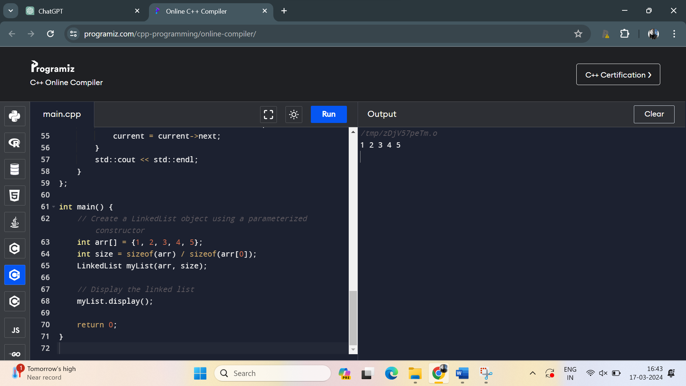

23. Develop a class **Polynomial** to represent polynomials. Implement a parameterized constructor to initialize the polynomial coefficients. Overload the addition operator (+) to add two polynomials.

Program:

#include <iostream>

#include <vector>

class Polynomial {

private:

std::vector<int> coefficients;

public:

// Parameterized constructor

Polynomial(const std::vector<int>& coeffs) : coefficients(coeffs) {}

// Overloaded addition operator (+)

Polynomial operator+(const Polynomial& other) const {

int maxDegree = std::max(coefficients.size(), other.coefficients.size());

std::vector<int> resultCoeffs(maxDegree, 0);

for (size_t i = 0; i < coefficients.size(); ++i) {

resultCoeffs[i] += coefficients[i];

}

for (size_t i = 0; i < other.coefficients.size(); ++i) {

resultCoeffs[i] += other.coefficients[i];

}

return Polynomial(resultCoeffs);

}

// Function to display the polynomial

void display() const {

for (int i = coefficients.size() - 1; i >= 0; --i) {

if (coefficients[i] != 0) {

std::cout << coefficients[i] << "x^" << i;

if (i != 0) {

std::cout << " + ";

}

}

}

std::cout << std::endl;

}

};

int main() {

// Create two Polynomial objects

Polynomial poly1({1, 2, 3}); // 3x^2 + 2x + 1

Polynomial poly2({-1, 0, 4}); // 4x^2 - x

// Add the polynomials using the overloaded addition operator

Polynomial sum = poly1 + poly2;

// Display the result

std::cout << "Polynomial 1: ";

poly1.display();

std::cout << "Polynomial 2: ";

poly2.display();

std::cout << "Sum: ";

sum.display();

return 0;

}

Output:

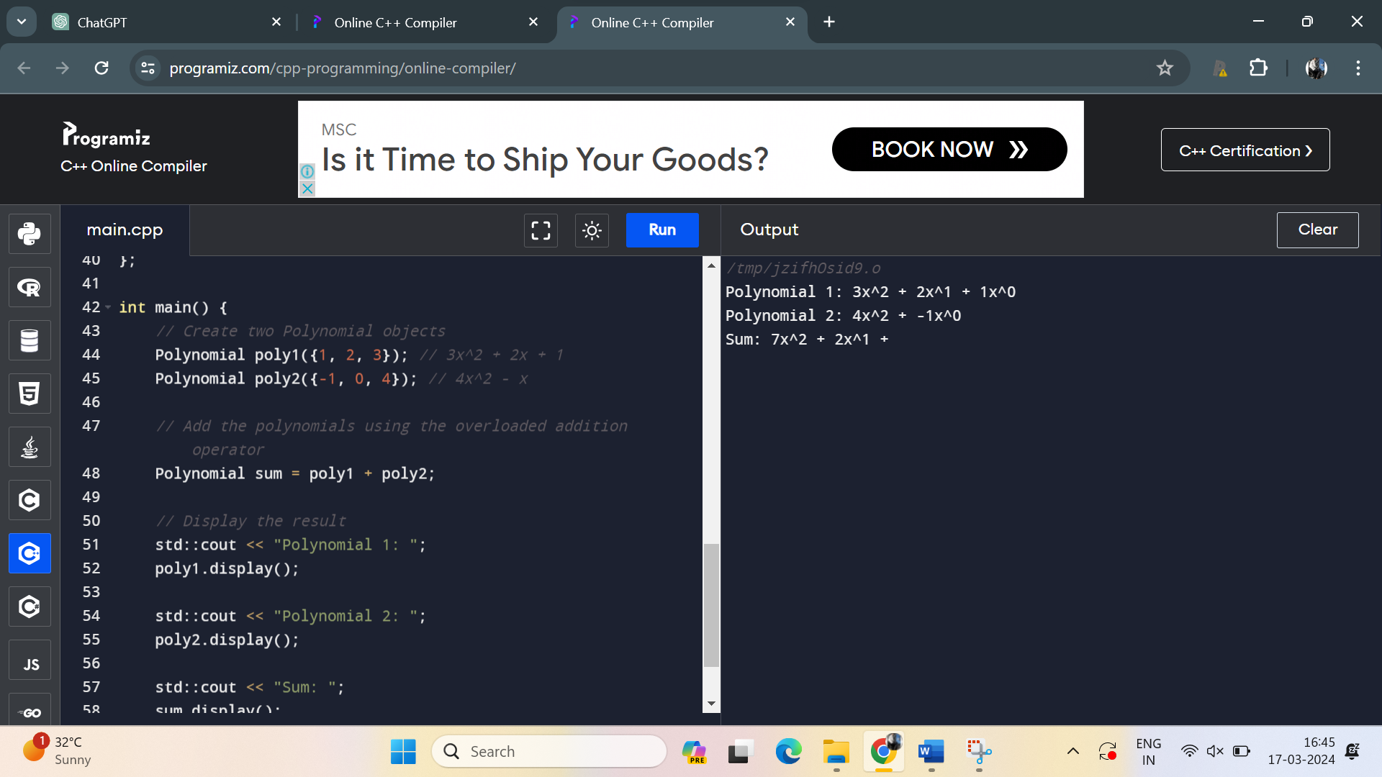

24. Write a class **Employee** to represent employees in a company. Implement a parameterized constructor to initialize employee details such as name, age, and salary. Overload the comparison operators (<, >) to compare employees based on their salaries.

Program:

#include <iostream>

#include <string>

class Employee {

private:

std::string name;

int age;

double salary;

public:

// Parameterized constructor

Employee(const std::string& n, int a, double s)

: name(n), age(a), salary(s) {}

// Overloaded comparison operator (<)

bool operator<(const Employee& other) const {

return salary < other.salary;

}

// Overloaded comparison operator (>)

bool operator>(const Employee& other) const {

return salary > other.salary;

}

// Function to display employee details

void display() const {

std::cout << "Name: " << name << ", Age: " << age << ", Salary: " << salary << std::endl;

}

};

int main() {

// Create Employee objects

Employee emp1("John", 30, 50000);

Employee emp2("Alice", 25, 60000);

// Compare employees based on salary

if (emp1 < emp2) {

std::cout << "Employee 1 earns less than Employee 2." << std::endl;

} else if (emp1 > emp2) {

std::cout << "Employee 1 earns more than Employee 2." << std::endl;

} else {

std::cout << "Employee 1 and Employee 2 have the same salary." << std::endl;

}

return 0;

}

Program:

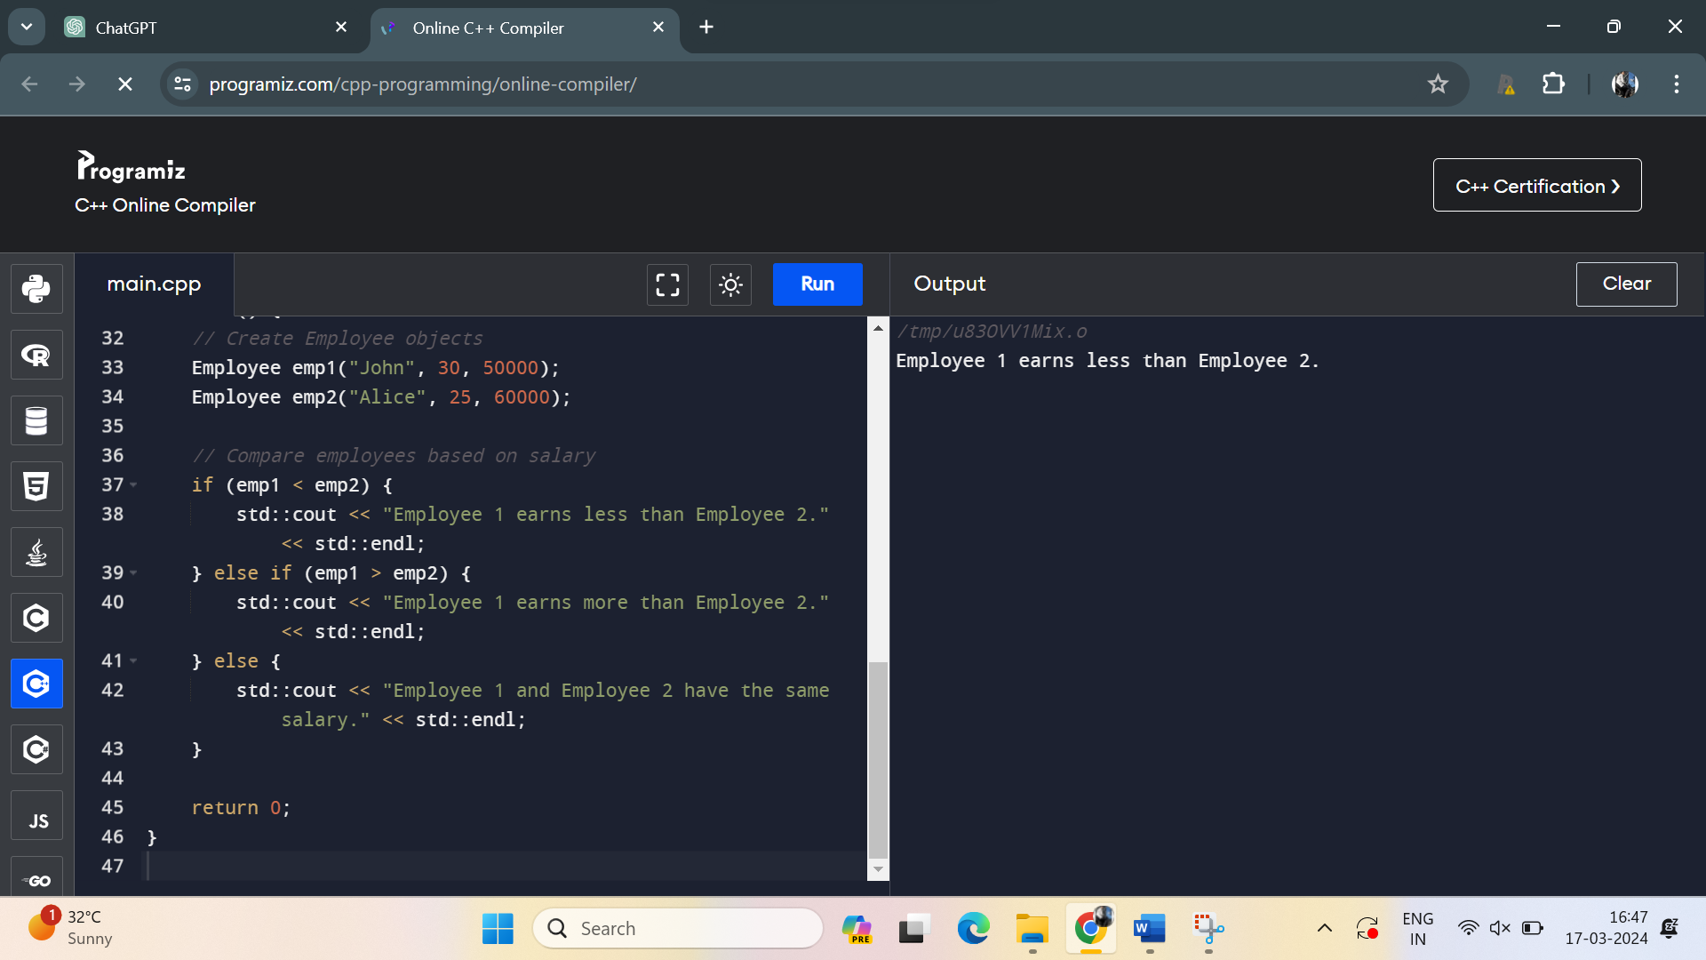

25. Define a class **BinarySearchTree** to represent a binary search tree. Implement a copy constructor to create a deep copy of the tree. Ensure proper memory management and handling of dynamically allocated nodes.

Program:

#include <iostream>

class BinarySearchTree {

private:

struct TreeNode {

int data;

TreeNode* left;

TreeNode* right;

TreeNode(int val) : data(val), left(nullptr), right(nullptr) {}

};

TreeNode* root;

// Helper function for copying tree recursively

TreeNode* copyTree(const TreeNode* node) {

if (node == nullptr) {

return nullptr;

}

TreeNode* newNode = new TreeNode(node->data);

newNode->left = copyTree(node->left);

newNode->right = copyTree(node->right);

return newNode;

}

public:

// Default constructor

BinarySearchTree() : root(nullptr) {}

// Copy constructor

BinarySearchTree(const BinarySearchTree& other) {

root = copyTree(other.root);

}

// Destructor (recursive)

~BinarySearchTree() {

clear(root);

}

// Function to clear the tree (recursive)

void clear(TreeNode* node) {

if (node != nullptr) {

clear(node->left);

clear(node->right);

delete node;

}

}

// Function to insert a value into the tree

void insert(int value) {

root = insertHelper(root, value);

}

// Helper function to insert a value into the tree (recursive)

TreeNode* insertHelper(TreeNode* node, int value) {

if (node == nullptr) {

return new TreeNode(value);

}

if (value < node->data) {

node->left = insertHelper(node->left, value);

} else if (value > node->data) {

node->right = insertHelper(node->right, value);

}

return node;

}

// Function to display the tree in inorder traversal

void inorderTraversal() const {

inorderHelper(root);

}

// Helper function to perform inorder traversal (recursive)

void inorderHelper(TreeNode* node) const {

if (node != nullptr) {

inorderHelper(node->left);

std::cout << node->data << " ";

inorderHelper(node->right);

}

}

};

int main() {

BinarySearchTree bst1;

bst1.insert(50);

bst1.insert(30);

bst1.insert(70);

bst1.insert(20);

bst1.insert(40);

// Display original tree

std::cout << "Original Tree (Inorder traversal): ";

bst1.inorderTraversal();

std::cout << std::endl;

// Create a deep copy of the tree

BinarySearchTree bst2 = bst1;

// Display copied tree

std::cout << "Copied Tree (Inorder traversal): ";

bst2.inorderTraversal();

std::cout << std::endl;

return 0;

}

Output:

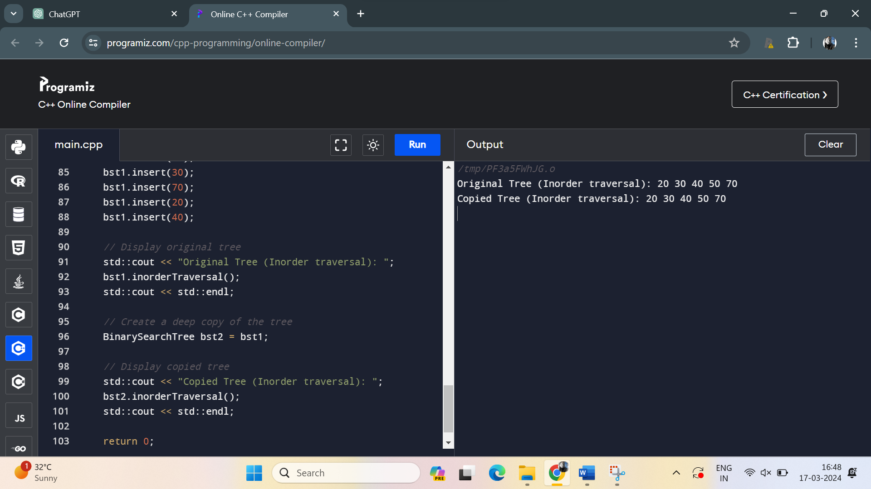

26. Create a class **Fraction** to represent fractions. Implement a parameterized constructor to initialize the fraction with numerator and denominator. Overload the division operator (/) to divide two fractions.

Program:

#include <iostream>

class Fraction {

private:

int numerator;

int denominator;

public:

// Parameterized constructor

Fraction(int num, int denom) : numerator(num), denominator(denom) {

if (denominator == 0) {

std::cerr << "Error: Denominator cannot be zero." << std::endl;

exit(1);

}

simplify();

}

// Function to simplify the fraction

void simplify() {

int gcdVal = gcd(numerator, denominator);

numerator /= gcdVal;

denominator /= gcdVal;

// Ensure the sign is on the numerator

if (denominator < 0) {

numerator *= -1;

denominator *= -1;

}

}

// Function to calculate the greatest common divisor (GCD)

int gcd(int a, int b) {

if (b == 0)

return a;

return gcd(b, a % b);

}

// Overloaded division operator (/)

Fraction operator/(const Fraction& other) const {

int num = numerator * other.denominator;

int denom = denominator * other.numerator;

return Fraction(num, denom);

}

// Function to display the fraction

void display() const {

std::cout << numerator << "/" << denominator;

}

};

int main() {

// Create two Fraction objects

Fraction frac1(3, 4);

Fraction frac2(2, 3);

// Perform division using the overloaded division operator

Fraction result = frac1 / frac2;

// Display the result

std::cout << "Result of fraction division: ";

result.display();

std::cout << std::endl;

return 0;

}

Output:

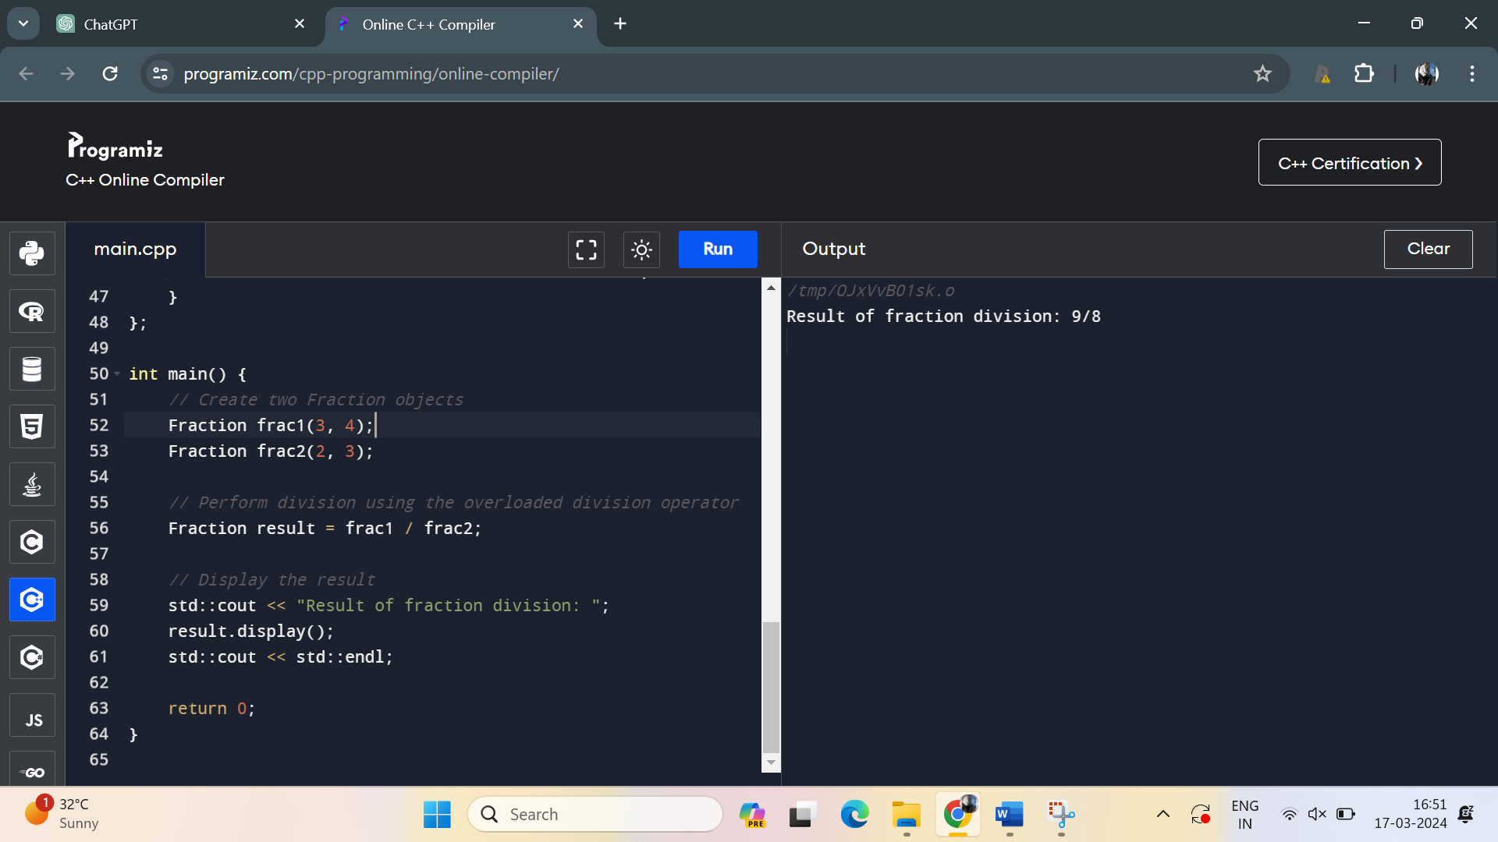

27. Implement a class **String** to represent strings. Include a copy constructor to perform a deep copy of the string. Overload the concatenation operator (+) to concatenate two strings.

Program:

#include <iostream>

#include <cstring>

class String {

private:

char* data;

public:

// Default constructor

String() : data(nullptr) {}

// Parameterized constructor

String(const char* str) {

if (str != nullptr) {

data = new char[strlen(str) + 1];

strcpy(data, str);

} else {

data = nullptr;

}

}

// Copy constructor (deep copy)

String(const String& other) {

if (other.data != nullptr) {

data = new char[strlen(other.data) + 1];

strcpy(data, other.data);

} else {

data = nullptr;

}

}

// Destructor

~String() {

delete[] data;

}

// Overloaded concatenation operator (+)

String operator+(const String& other) const {

int len1 = data ? strlen(data) : 0;

int len2 = other.data ? strlen(other.data) : 0;

char* result = new char[len1 + len2 + 1];

if (data) {

strcpy(result, data);

} else {

result[0] = '\0';

}

if (other.data) {

strcat(result, other.data);

}

return String(result);

}

// Function to display the string

void display() const {

if (data) {

std::cout << data;

}

}

};

int main() {

// Create two String objects

String str1("Hello, ");

String str2("world!");

// Concatenate the strings using the overloaded concatenation operator

String result = str1 + str2;

// Display the concatenated string

std::cout << "Concatenated string: ";

result.display();

std::cout << std::endl;

return 0;

}

Output:

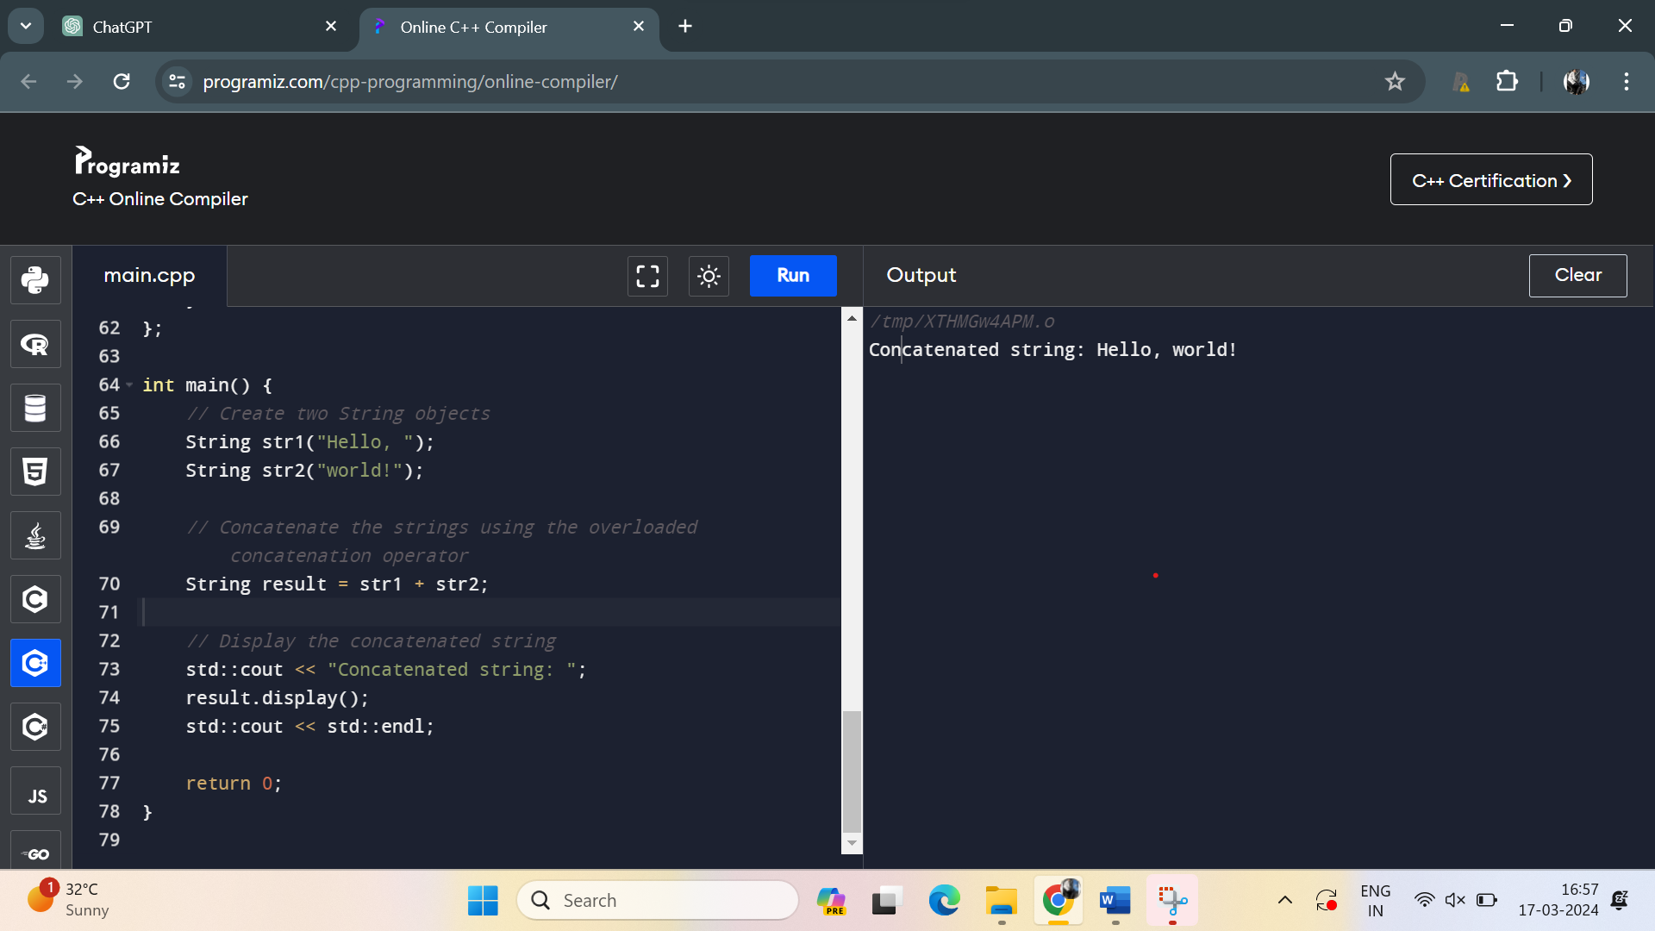

28. Develop a class **Polynomial** to represent polynomials. Implement a parameterized constructor to initialize the polynomial coefficients. Overload the multiplication operator (*) to multiply two polynomials.

Program:

#include <iostream>

#include <vector>

class Polynomial {

private:

std::vector<int> coefficients;

public:

// Parameterized constructor

Polynomial(const std::vector<int>& coeffs) : coefficients(coeffs) {}

// Overloaded multiplication operator (*)

Polynomial operator*(const Polynomial& other) const {

int degree1 = coefficients.size() - 1;

int degree2 = other.coefficients.size() - 1;

std::vector<int> resultCoeffs(degree1 + degree2 + 1, 0);

for (int i = 0; i <= degree1; ++i) {

for (int j = 0; j <= degree2; ++j) {

resultCoeffs[i + j] += coefficients[i] * other.coefficients[j];

}

}

return Polynomial(resultCoeffs);

}

// Function to display the polynomial

void display() const {

int degree = coefficients.size() - 1;

for (int i = degree; i >= 0; --i) {

if (coefficients[i] != 0) {

if (i != degree) {

std::cout << " + ";

}

if (i == 0) {

std::cout << coefficients[i];

} else {

std::cout << coefficients[i] << "x^" << i;

}

}

}

std::cout << std::endl;

}

};

int main() {

// Create two Polynomial objects

Polynomial poly1({1, 2, 3}); // 3x^2 + 2x + 1

Polynomial poly2({-1, 0, 4}); // 4x^2 - x

// Multiply the polynomials using the overloaded multiplication operator

Polynomial result = poly1 * poly2;

// Display the result

std::cout << "Result of polynomial multiplication: ";

result.display();

return 0;

}

Program:

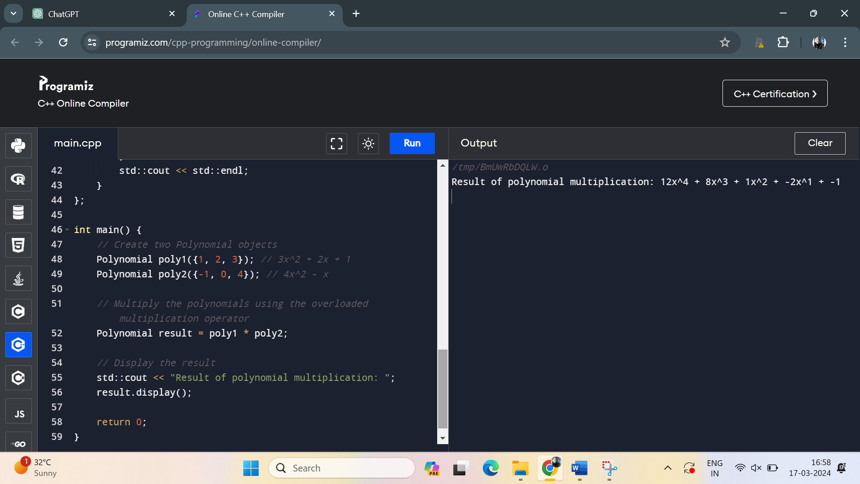

29. Write a class **BigInt** to represent arbitrarily large integers. Implement a parameterized constructor to initialize the integer with a string representation. Overload the addition operator (+) to add two BigIntegers.

Program:

#include <iostream>

#include <string>

#include <algorithm>

class BigInt {

private:

std::string digits;

public:

BigInt(const std::string& num_str) : digits(num_str) {}

BigInt operator+(const BigInt& other) const {

std::string result;

int carry = 0;

int i = digits.size() - 1;

int j = other.digits.size() - 1;

while (i >= 0 || j >= 0 || carry) {

int sum = carry;

if (i >= 0) {

sum += digits[i] - '0';

i--;

}

if (j >= 0) {

sum += other.digits[j] - '0';

j--;

}

carry = sum / 10;

result.push_back((sum % 10) + '0');

}

std::reverse(result.begin(), result.end());

return BigInt(result);

}

friend std::ostream& operator<<(std::ostream& os, const BigInt& num) {

os << num.digits;

return os;

}

};

int main() {

BigInt num1("123456789012345678901234567890");

BigInt num2("987654321098765432109876543210");

BigInt sum_num = num1 + num2;

std::cout << "Sum: " << sum_num << std::endl;

return 0;

}

Output:

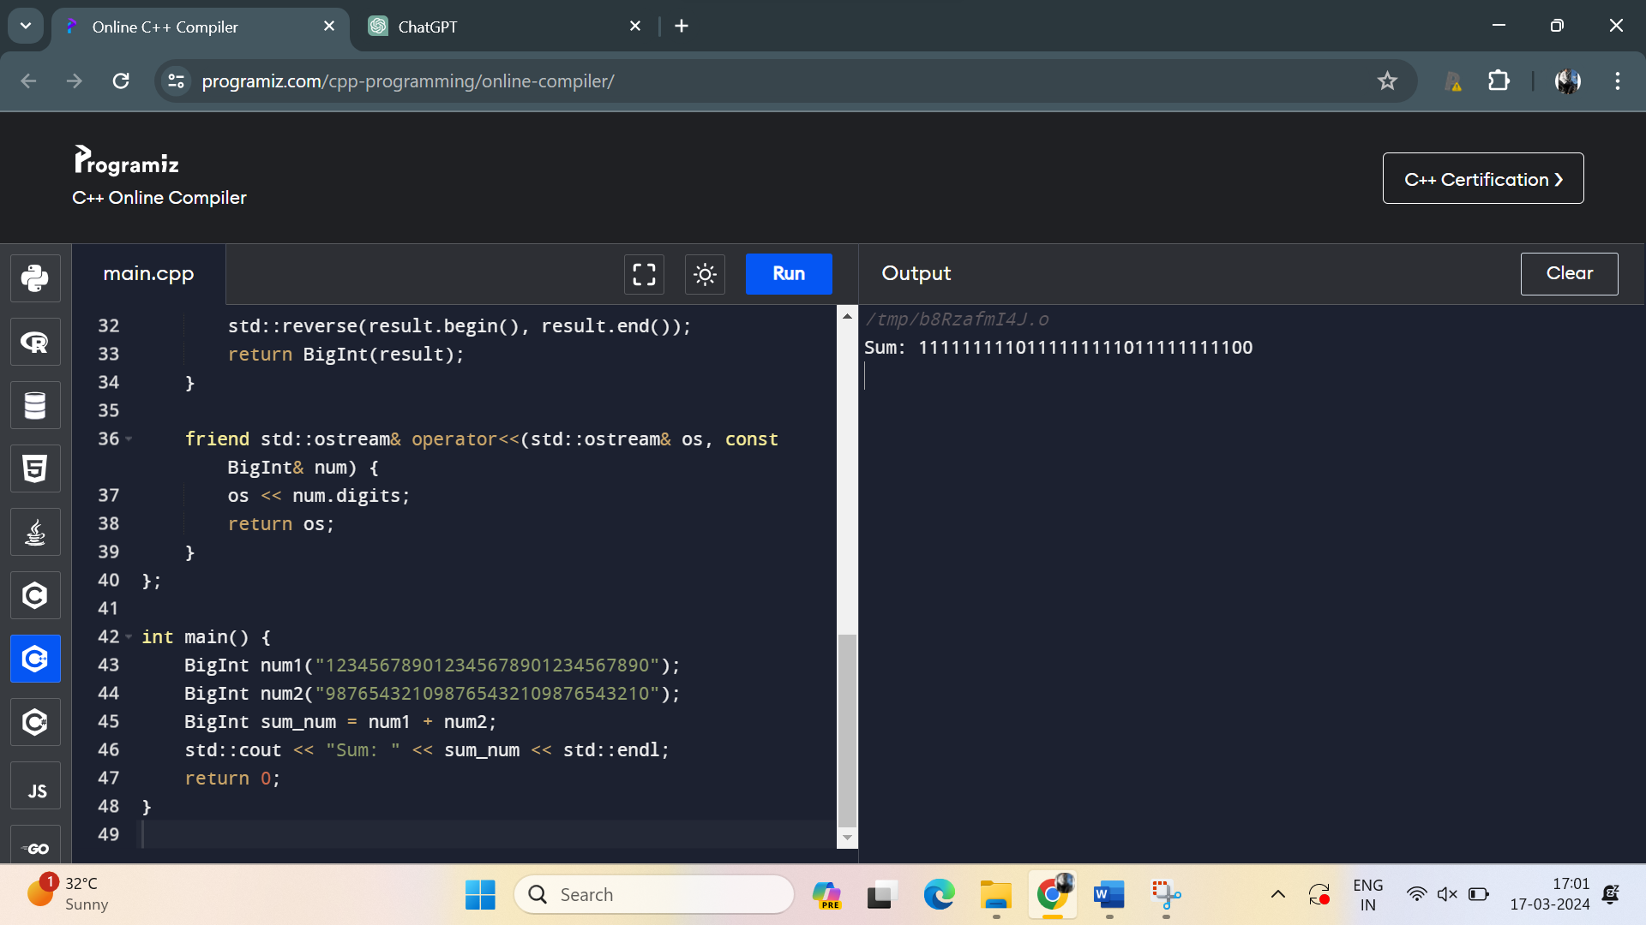

30. Create a class **Stack** to represent a stack data structure. Implement a copy constructor to create a deep copy of the stack. Ensure proper memory management and handling of dynamically allocated nodes.

Program:

#include <iostream>

class Stack {

private:

struct Node {

int data;

Node* next;

Node(int val) : data(val), next(nullptr) {}

};

Node* top;

public:

// Constructor

Stack() : top(nullptr) {}

// Destructor

~Stack() {

while (top != nullptr) {

Node* temp = top;

top = top->next;

delete temp;

}

}

// Copy Constructor (deep copy)

Stack(const Stack& other) : top(nullptr) {

if (other.top != nullptr) {

// Copy the top node

top = new Node(other.top->data);

Node* current = top;

Node* otherCurrent = other.top->next;

// Copy remaining nodes

while (otherCurrent != nullptr) {

current->next = new Node(otherCurrent->data);

current = current->next;

otherCurrent = otherCurrent->next;

}

}

}

// Push operation

void push(int val) {

Node* newNode = new Node(val);

newNode->next = top;

top = newNode;

}

// Pop operation

void pop() {

if (top == nullptr) {

std::cout << "Stack is empty. Cannot pop.\n";

return;

}

Node* temp = top;

top = top->next;

delete temp;

}

// Check if the stack is empty

bool isEmpty() const {

return top == nullptr;

}

// Display the stack

void display() const {

Node* current = top;

std::cout << "Stack: ";

while (current != nullptr) {

std::cout << current->data << " ";

current = current->next;

}

std::cout << std::endl;

}

};

int main() {

// Example usage

Stack originalStack;

originalStack.push(1);

originalStack.push(2);

originalStack.push(3);

// Display original stack

std::cout << "Original ";

originalStack.display();

// Create a deep copy of the original stack

Stack copiedStack(originalStack);

// Modify the original stack

originalStack.pop();

originalStack.push(4);

// Display both stacks

std::cout << "Original ";

originalStack.display();

std::cout << "Copied ";

copiedStack.display();

return 0;

}

Output:

